Note for CIVICS Journals -- should have vertical S-M-A-R-T -- the students will fill in what each letter means

MATERIALS:
Powerpoint (provided)
CIVICS journals, writing utensils
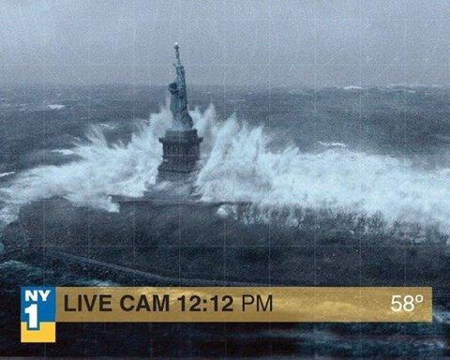
Introduction:
- What seems wrong with this picture? Anything? Nothing? This was a photo that circulated around facebook after Hurricane Sandy, a hurricane that hit New York and New Jersey in 2012.
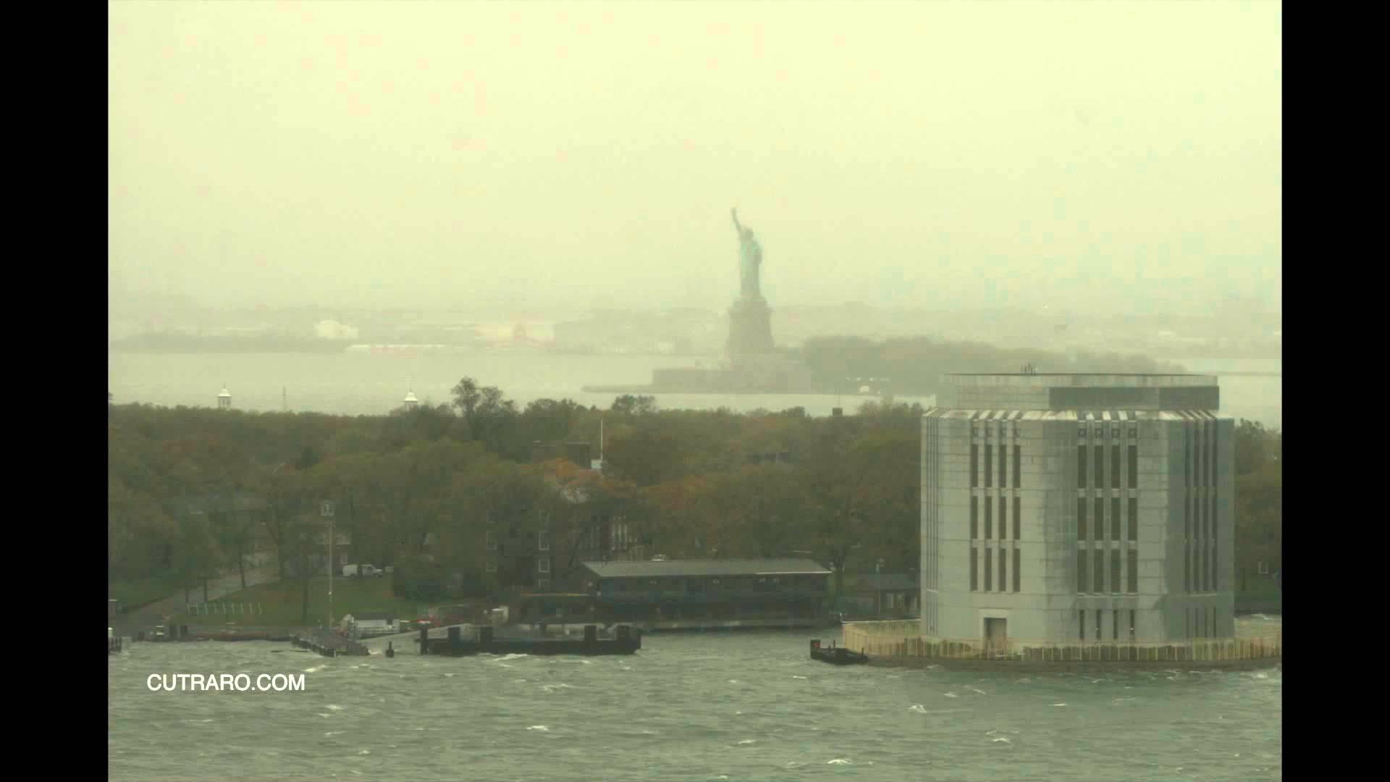
- The problem is that it isn’t real. This is a photo from a movie called The Day After Tomorrow that was released in 2004.
- This is what the Statue of Liberty actually looked like: A lot more boring, right?
- Brainstorm reasons for why a photo like this would have circulated. Why would someone make it? Why would people share it?

DIscussion:
- Begin with a brief discussion of how students get their information. How do they learn about the world around them?
- Build a working definition for media as a group (The main means of mass communication (broadcasting, publishing, and the Internet) regarded collectively). What types of media are there?
- Has anyone ever heard a story they knew wasn’t true? Have they seen other people believe it? Have they believed it?
- Explain that there is a difference between biased/opinion pieces, and actually false pieces. As television and the internet have become more popular, it has become easier to spread information that is biased...and in some cases even false.
  - If you want to show an example of how two different media sources can show two different sides of something, show the first 30 sec - 1 min of this clip below (SLIDES):
    - https://qz.com/794553/video-who-won-the-first-presidential-debate-depends-on-which-network-you-watched/
- But then, there are some things that aren’t just opinion. Remember the photo at the beginning? That’s just plain false.
- Today, we’re going to discuss strategies to be a detective of sorts, and figure out whether what you hear or read is actually true. Have the students open up their CIVICS Journals to the page for today, which should have the letters SMART on it.
- Using the whiteboard, explain the SMART framework in the way that best suits your students. Have the students write down a few words each to explain the framework.
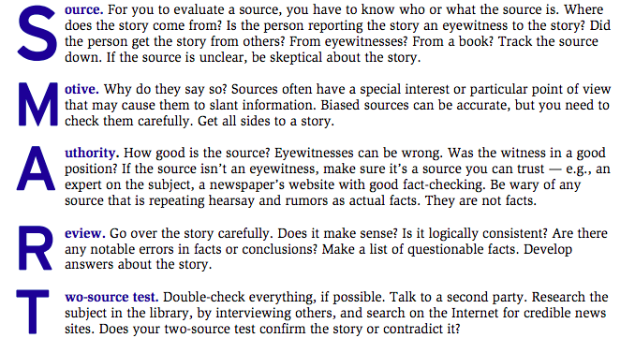
Scenario Activity:
- Split the students into several groups. Have each group take on of the following scenarios and apply the framework to decide if the news if real or not trustworthy.
- Students should write down their thoughts in the booklet. Circle around the room to ensure that they’re on the right track, asking them to explain their thinking or suggesting why they might want to think differently if necessary. You can ask the classroom teacher to help you with this if they’re available. If time, have them present their findings, but if time’s not available, just have them check with you at the end of class.

Scenarios:
- A new website that was created yesterday called The Clementine Report publishes an article that says that all oranges grown in California are poisonous because of a spill from a toxic waste plant. The report says that the news comes from scientists, but doesn’t say who the scientists are. It has pictures of brown and green oranges on the website, but there are no sources for the photos.
- One of your aunts posts a link on Facebook to an article from the Washington Post, a newspaper that was founded in 1877. The article title is “2017 was among the planet’s hottest years on record, government scientists report.” The article quotes Gavin Schmidt, director of NASA’s Institute for Space Studies, and Bob Ward, who is policy director for an institute at the London School of Economics, a university in England. Both of them say that their opinions are based on data from the government, and there are graphs in the article.
- A friend of yours posts an article on twitter from a website that you don’t recognize that says that Japanese scientists have figured out how to grow plants from water in rocks on Mars. The article shows a plant growing out of a rock on earth, and says that the Japanese scientists have done the same thing with a rocket that they landed on Mars one year ago. You can’t remember hearing about the rocket launch, but maybe you just didn’t know about it. There are no pictures from Mars in the article.
- It’s June, and you see an article on the internet that says that it snowed three feet in Virginia today. It’s nearly 80 degrees in Chapel Hill, but there are photos in the article of snow-capped mountains and other photos of buildings and cars covered in snow. You can’t tell where the photos were taken, and there are no sources underneath the photos. You look up the weather for Virginia on the internet and it says that it’s 50 degrees and partly sunny.
- You come across an article on the website Health-Care-Matters.com about a new Health Care law that a political party is going to pass through Congress in 2018. The article talks about how great the new law is going to be, and uses quotes from several Senators. There are links in the article to the Washington Post (a real newspaper), NPR (a real radio network), and the Wall Street Journal (a real newspaper).
- A friend of your from another school sends you an email saying that he heard that the school superintendent for North Carolina had been fired. He sends a link to a website that doesn’t have a title, but that has a post about how the superintendent was fired. It has quotes from several people, but you don’t know who they are and none of them work at your school. At the bottom of the website there’s a place for you to put in your credit card number, and the website says you will win BIG PRIZES if you put in your number.

Wrap up:
- If time, have students present. But if there’s not enough time, that’s okay.
- Remind the students that this strategy works for a lot of different types of news, not just articles on the internet.
- Tie together any loose ends and set the stage for the following week.

SMART framework and scenario concept courtesy of Leon, Esmerelda, and Damon Huss. “Understanding ‘Fake News’” Civics on Call, Constitutional Rights Foundation, 3/30/17

