BRIEFING
Chancellor Carol Folt
***Must be submitted 10 days prior to event***

EVENT INFORMATION

Event Name: University Awards for the Advancement of Women

Event Date/Time: Monday, March 5th 2pm-3pm (Chancellor arrives by 2:20pm)

Venue Address: Pleasants Family Room, Wilson Library

Logistics: (i.e. travel/parking arrangements): Walk from South Building

Event Description:
Note: Please include statistics or figures about program/dept, etc.
Ceremony to celebrate and give University Awards for the Advancement of Women; 4 awards: faculty, staff, undergrad student, grad/professional student

Awards recognize “contributions to the advancement of women at the University of North Carolina at Chapel Hill and, in particular, for people of all genders who have contributed in one or more of the following ways:
- Elevated the status of women on campus in sustainable ways;
- Helped to improve campus policies affecting women;
- Promoted and advanced the recruitment, retention, and upward mobility of women;
- Participated in and assisted in the establishment of professional development opportunities for women; and/or
- Participated in and assisted in the establishment of academic mentoring for women.”

Chancellor’s Role: Present awards

Objectives: Present awards, recognize all people on campus who work towards gender equity

Organizers: Clare Counihan, 734.904.0796, clarecounihan@unc.edu; Claire Caudill claire.caudill@unc.edu

On-Site Point person: Claire Caudill, claire.caudill@unc.edu, 919-475-1771

Author of this briefing: Clare Counihan/Claire Caudill

Audience/Size: ~80 in attendance, including VCs, deans, members of selection committee, former winners, nominees, campus advocates

Notable Attendees (include phonetic spellings, important biographical information and notes, as necessary (i.e. where she’s met them before)):

Recipients
- Marcey L. Waters (faculty)
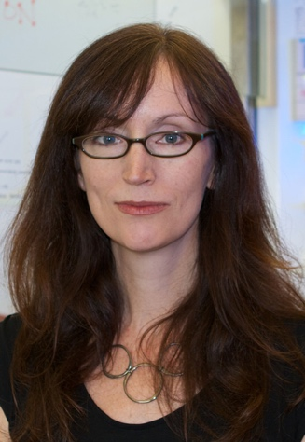

- Glen H. Elder, Jr., Distinguished Professor of Chemistry
- From nomination:
  - “helped attract and advance female PhD students in the department, as exemplified by the fact that 52% (15 of 29) of the PhD graduates from Marcey’s group have been women (compared to a national average of 32% women in PhD programs in the physical sciences; in chemistry specifically, the percentage is only 27%).
  - First advisor for grad student organization AM WISE (Advocates for Minorities and Women in Science and Engineering)
  - As first UNC WOWS (Workign on Women in Science) Scholar, co-organized the “Summit on Women in Science” (2013); also advocated to expand Target of Opportunity hires for STEM fields to include women

- Emily Hagstrom (undergrad)

- Senior majoring in Public Policy and Political Science and minoring in Women’s and Gender Studies.
- Honors thesis in Public Policy focuses on Early Childhood Education in France, with particular emphasis on inclusion of minority populations
- Co-chair of CAGE (Carolina Advocates for Gender Equity (CAGE), senior print editor of The Siren: UNC's Feminist Magazine, and founder and editor of the Campus Y Undergraduate Journal for Social Justice
- Moxie Scholar, Buckley Public Service Scholar, MacRae scholar
- Policy intern with national Women’s Law Center
- From nominations:
  - Founder of the Feminist Coalition, which brings together student and community feminist organizations for networking and collaboration
  - Created and conducting programming, through her work study position with the CWC, “to engage students in gender equity, including media literacy workshops on media and rape culture, [and] provisions and uses of Title IX”
  - Got CAGE recognized as an NGO by the UN so that she and CAGE co-chair can attend the UN’s 62nd Comission on the Status of Women (during spring break) as participants

- Erica R. Wallace (staff)
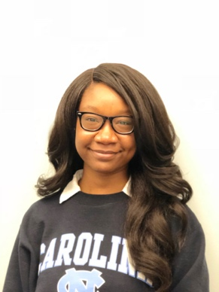

- Coordinator for Peer Mentoring and Engagement in the Center for Student Success and Academic Counseling
- Co-founder and current chair of the Womxn of Worth Advisory Board. The mission of the Womxn of Worth Initiative is to create and sustain a community for womxn of color and womxn who identify as members of underrepresented racial and ethnic populations that will promote academic excellence, holistic student success and wellness, identity development, and sisterhood.
- From nominations:
  - From work study students: “Wallace has provided a space [for us] to be unapologetically fierce, vulnerable, curious, and ambitious through the celebration of our racial and ethnic identities and womanness”
  - Erica has “really been the backbone and driving force behind [the Womxn of Worth Initiative]. Her dedication to implementing a space for women of color can be seen through the countless hours she puts in to organize events all while managing several work study students and attending grad school”

- Francesca Bernardi & Katrina Morgan (graduate and professional)
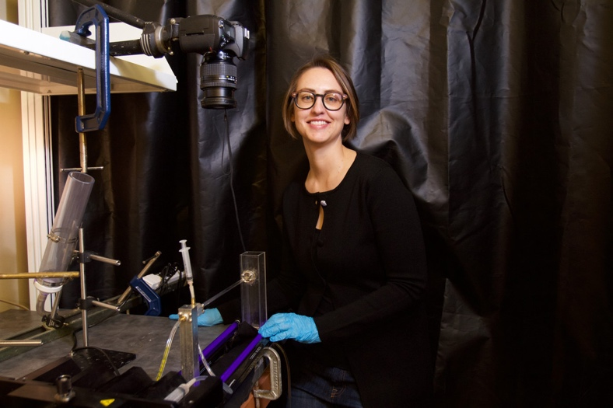
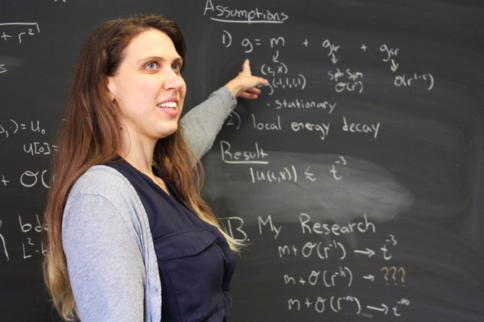

- Bernardi: Ph.D. candidate in Applied Mathematics, studying Fluid Dynamics in the UNC Fluids Lab. She is graduating in May and will be moving to Florida State University for a postdoc
- Morgan: 4th-year Ph.D. candidate in Pure Mathematics studying Partial Differential Equations
- Co-founders of Girls Talk Math summer camp: two week, free day camp for rising girl-identified 9th – 12th graders that encourages girls’ confidence with math and teaches about women mathematicians’ contributions through history
- Co-founders of the local graduate chapter of Association of Women in Mathematics; supported creation of undergrad chapter as a student organization; mentoring pairs
- From nominations:
  - “Francesca has dedicated herself to supporting her fellow female mathematicians by creating and sustaining various initiatives, and her efforts have had a phenomenally positive impact on the lives of so many women”
  - “I fully susect that several stron female students in STEM fields will be arriving at UNC as a direct result of [Katrina’s] efforts. And moreover, I believe that these students will be arriving with preparedness and confidence that will all but guarantee their success

Public/Private Event: invitation only
Media Contact (if any): NA
Media Attendance: Yes: Jon Gardiner

Program/Run of Show:

2:00 pm Reception opens
2:30 pm Gloria Thomas opens/formally welcomes, introduces Chancellor Folt
Chancellor Folt presents awards (4 recipients – each receive plaque + check)
Gloria Thomas thanks for attending and resume mingling
3:00 pm END (Chancellor and recipients gather for photos)

Organization Information/Background:
CHANCELLOR’S REMARKS

- Introductions:
  - Introduced by Gloria Thomas, Director, Carolina Women’s Center, who will welcome audience
  - At the end of remarks, turn back over to Gloria Thomas for thanks and resuming reception
- Acknowledgements:
  - Selection Committee: faculty, staff, and student representatives (undergrad, grad) from across university:
- Jocelyn Chua
- Beth Moracco, Chair (Mor-ock-o)
- Crystal King
- Sarah Leck
- Madelyn Percy
- Bob Pleasants
- Lillie L. Searles
- Felicia Washington

- Stories/Anecdotes: Chancellor Folt likes to include anecdotes/stories when delivering remarks. Please provide us with information from which we can craft anecdotes such as:
  - Presided/awarded last year
  - How does the Carolina community fit into the narrative of this event? This event recognizes UNC community’s ongoing journey and commitment to gender equity;
  - Does Chancellor Folt have personal experiences that can tie into the purpose of this event?

- Key Points: Please provide recommendations for 3-5 high-level key points in narrative form. This could include facts/figures about a program/person or answer some of the following questions:
  - Why is this event happening? To recognize individuals who have advanced women’s equity systemically and systematically
  - What’s the significance of this event? Time to pause and reflect on community’s journey towards gender equity, the progress the university continues to make; recognize the impact the awardees have on the individuals around them as well as the university as a whole, both through the service they provide and the role modeling for inspiration they do
Brief bios of Recipients:
FACULTY: Marcey L. Waters
Marcey Waters grew up in California and earned a bachelor’s degree in Chemistry from the University of California, San Diego. She then went on to the University of Chicago for her PhD followed by postdoctoral research at Columbia University. She began her independent career at UNC in 1999 and rose through the ranks to full professor while establishing an internationally recognized research program at the interface of chemistry and biology. She is currently the Glen H. Elder, Jr., Distinguished Professor of Chemistry. Her interests include applications of organic chemistry to biological problems, advocating for women in science, and her two daughters.

STAFF: Erica Wallace
Since 2015, Erica Wallace has served as the Coordinator for Peer Mentoring and Engagement in the Center for Student Success and Academic Counseling here at UNC. She is a native of Charlotte, North Carolina and has earned degrees from Davidson College and Clemson University; she is current working on her doctorate at the University of North Carolina at Greensboro. In her role here at Carolina, she actively engages with students involved in the Minority Advisory Program, Carolina Covenant Peer Mentoring Program, and Carolina Student Transfer Excellence Program (C-STEP). She endeavors to be an educator who recognizes and cultivates students’ potential, a mentor who is supportive and trustworthy, and an advocate who encourages and implements change while never accepting the status quo.

Erica likes to joke that there is the job she is paid to do and the job she actually does. In addition to managing the three peer mentoring programs and interacting with their participants, Erica is the current chair of the Womxn of Worth Advisory Board. The mission of the Womxn of Worth Initiative is to create and sustain a community for womxn of color and womxn who identify as members of underrepresented racial and ethnic populations that will promote academic excellence, holistic student success and wellness, identity development, and sisterhood. Erica co-founded, with 2 former Carolina Housing colleagues, this collaborative campus effort involves undergraduate students, graduate students, and faculty and staff from various departments. Living with the multiple marginality of being a woman of color can feel like being an outsider-within, both invisible and hypervisible. Erica recognizes that in order for a campus, a community, and a society to truly be inclusive, we have to make space for those located in the margin and to create spaces of, to borrow a phrase from bell hooks, “radical openness and possibility.” This is what she works toward, collectively through the programs and individually with the students entrusted in her care. She makes space for each student she encounters to be seen as a priority, to be heard loud and clear, and to just be their authentic selves. Erica is proud to be a part of the Carolina community to assist students in their development as scholars and human beings and to continuously work toward an inclusive and enlightened Carolina.

GRAD/PROF STUDENT: Francesca Bernardi and Katrina Morgan
Francesca Bernardi
Francesca is a Ph.D. candidate in Applied Mathematics, studying Fluid Dynamics in the UNC Fluids Lab. She is graduating in May and will be moving to Florida State University for a postdoctoral appointment in the Fall of 2018. She is the 2017 winner of the Linker Award for excellence in undergraduate teaching in the Department of Mathematics. She is also receiving a Graduate Certificate in Women’s and Gender Studies here at UNC. She co-founded the Girls Talk Math camp with Katrina Morgan and has been the President of the local Association for Women in Mathematics chapter for the past two years.

Katrina Morgan
Katrina Morgan is a fourth-year Ph.D. candidate in Pure Mathematics studying Partial Differential Equations. Her research examines how the equation that describes wave behavior changes in the context of curved geometries. She shares her love of mathematics with women and girls through programs like the Girls Talk Math summer camp and the Association for Women in Mathematics Triangle Conference, both of which she co-founded with Francesca Bernardi, as well as through teaching and mentoring. She has held leadership roles, including Treasurer and President, in the local Association for Women in Mathematics Chapter since Fall 2015. She is also passionate about science communication and literacy and has been published on the Scientific American blog.

UNDERGRAD: Emily Hagstrom
Emily Hagstrom is a writer, researcher, and activist. She’s a senior majoring in Public Policy and Political Science and minoring in Women’s and Gender Studies. Her honors thesis in Public Policy focuses on Early Childhood Education in France, with particular emphasis on inclusion of minority populations. Other research interests include Title IX Policy, violence prevention, LGBTQ+ health, and reproductive justice. She has worked with Women AdvaNCe, the Orange County Rape Crisis Center, the National Women’s Law Center, and the Feminist Majority. Emily currently serves in the leadership of the following student groups: co-chair Carolina Advocates for Gender Equity (CAGE), senior print editor of The Siren: UNC's Feminist Magazine, and founder and editor of the Campus Y Undergraduate Journal for Social Justice. She works as a program developer at the Carolina Women's Center.

