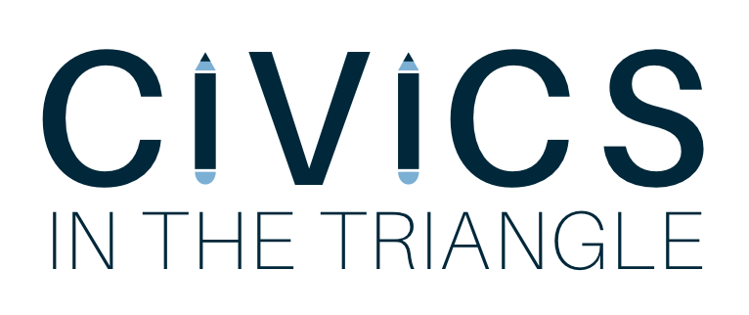

University of North Carolina
Fall 2017-Spring 2018 Logistical Plan

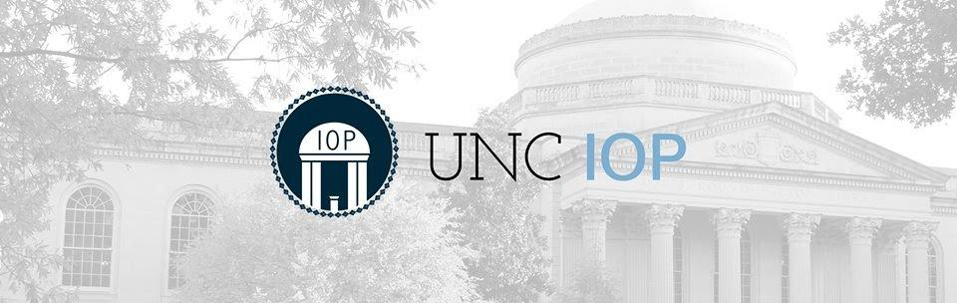
By Lucy Russell

Program Description
Civics in the Triangle will place motivated UNC-Chapel Hill undergraduates in elementary school classrooms, teaching civics and government classes to inspire students to immerse themselves in their local communities and grow into active participants in our democracy. The program will work with two public schools in the Chapel Hill/Carrboro area during the 2017-2018 school year. We are tailoring our program to meet the needs of 4th and 5th grade classrooms over an 8-week long period every Fall and Spring. By focusing on these grades, we will be able to follow a student’s transition to the subsequent grade level over the course of two years. Choosing 4th and 5th grades allows us to develop a curriculum that builds upon itself, thus maximizing the impact on students’ educations. This helps us to track progress in their learning and measure the effectiveness of our lessons.
Civics in the Triangle is modeled after Harvard University’s corresponding CIVICS program, a student organization under its Institute of Politics. While Harvard’s program has existed for years and is of a much larger scale than UNC-Chapel Hill’s one, it serves as an enlightening example for the development of ours. The current and former Program Chairs of Harvard CIVICS have been instrumental in guiding the creation of our program.

Our Teaching Philosophy
Justice Sandra Day O’Connor, the first woman on the U.S. Supreme Court, famously noted "The practice of democracy is not transferred through the gene pool. It must be taught and learned anew by each generation of citizens.”
Civics in the Triangle aims to capitalize on the talented and diverse UNC-Chapel Hill student body by giving civic-minded individuals an outlet to share their passions in local schools and to inspire the next generation of equally diverse students in North Carolina. We will use classroom lessons to instill motivation in the elementary school students to become active citizens and better their community. Our democracy is only as strong as the engagement of its citizens, making our program’s important mission of creating a more educated and involved citizenry necessary.
Our program has a unique opportunity to utilize our classroom time in an engaging and creative fashion. Ken Robinson, an internationally recognized leader in education, argues in his book “Creative Schools” that teachers must harness creativity in order to tailor a powerful, individualized approach to lessons in the classroom. He proposes a teaching method that utilizes today’s unprecedented technological resources to develop a love of learning in all students and to foster innovative minds that will create solutions for our modern challenges. We aimed to mirror the eight core competencies of his theoretical, ideal curriculum in the formation of our lessons:
- Curiosity- the ability to ask questions and explore how the world works.
- Creativity- the ability to generate new ideas and to apply them in practice.
- Criticism- the ability to analyze information and ideas and to form reasoned arguments and judgments.
- Communication- the ability to express thoughts and feelings clearly and confidently in a range of media and forms.
- Collaboration- the ability to work constructively with others.
- Compassion- the ability to empathize with others and to act accordingly.
- Composure- the ability to connect with the inner life of feeling and develop a sense of personal harmony and balance.
- Citizenship- the ability to engage constructively with society and to participate in the processes that sustain it.
While the core of our program relies on furthering the competency of ‘citizenship’, the remaining values can be used as tools to help students effectively absorb the lessons. By focusing on these eight themes throughout the curriculum, we aim to prepare students to be active citizen-leaders in an increasingly complex and interdependent world.

Our Curriculum
The three pillars of our curriculum are: civics, American history, and government. The curriculum is built to both motivate and challenge elementary school students without assuming extensive prior knowledge of American history. There will be a preliminary assessment to gauge where the class is at in terms of history and civics knowledge, which can be used to compare with a final assessment to measure how much students learned.
The lessons enable students to rationalize their everyday perceptions of current events and American culture within the context of citizenship that is both non-partisan and encouraging of diversity.
Because our volunteers have more flexibility than CHCSS teachers in terms of curriculum requirements, it gives them the autonomy to create innovative lessons that encourage students’ curiosity. Our volunteers have the opportunity to lead lessons that emphasize their own passions and allow for their contagious enthusiasm to spread to younger students.
We want to provide lessons that are relevant, interactive, and engaging for our students. Our curriculum will be organized, easy to teach, and consistent between different classrooms. There will be separate curriculums for the 4th and 5th grades, adjusted accordingly for their educational levels and maturity.
Our lessons are built on the premise that one develops critical thinking skills through participation, not passive listening. Thus, teaching in the classroom is viewed as a dialogue, not a lecture. All of our lessons are interactive and involve skits, crafts, videos, audio recordings, games, and visual aids. They will also use a limited range of traditional teaching methods, including very brief talks with key ideas and notes written on the blackboard. Other components include bringing texts to the classroom and expanding school libraries or using manipulatives such as maps.
Many organizations currently have a plethora of online resources to help develop an extensive curriculum. Carolina K-12 (formerly the NC Civic Education Consortium) is a program of UNC-Chapel Hill’s Carolina Public Humanities and works to extend the resources of the University to North Carolina’s K-12 educators. Its website features a variety of lesson plans that will be implemented in the curriculum. We are partnering with Carolina K-12 to create a curriculum that aligns with North Carolina standards. Another valuable resource is iCivics, an organization founded by Justice O’Connor that provides teachers with well-written, inventive, and free online resources online to enhance their practice and inspire their classrooms.
In addition to using Robinson’s research to direct the formation of our curriculum, we are also adhering to the North Carolina literacy standards for elementary schools. The program is designed to enhance the pre-existing education standards for 4th and 5th grades, specifically. The lessons will supplement the 4th and 5th grade Social Studies Strands that are listed below. The goal of the program is to provide additional, dynamic instruction in civics that will assist CHCSS Social Studies teachers. By aligning the curriculum with the literacy standards and Social Studies strands, the program will serve as a compliment to preexisting instruction in these areas by CHCSS teachers. The program has a multifaceted impact that benefits the UNC student volunteers, the CHCSS teachers, and the 4th and 5th grade students.
Spiraling of 4-5 Social Studies Strands

 | History | Geography & Environmental Literacy | Economic & Personal Financial Literacy | Culture | Civics & Government
4th | Significant use of historical narratives to teach multiple perspectives and identify change over time  Focus on NC history | How human, environmental, and technological factors influenced change in NC | Understand concepts of entrepreneurship, economic decision-making, econ. development, & market economy in relation to the life in NC and personal choices | Understand impact of various cultural groups in NC | Understand the development, functions and organization of US government (NC Constitution)
5th | Significant use of historical narratives to teach historical thinking skills  Assess the validity of historical sources using a variety of interpretive tools  Focus on US history (Pre-Colonial - Reconstruction) | How human , environmental, and technological factors influenced change in US | Understand concepts of entrepreneurship, economic decision-making, econ. development, & market economy (and other concepts) in relation to life in US and consequences of personal choices. | Understand the impact of the diverse, cultural groups on the US (migration, settlement, patterns, and economic development) | Understand the development, functions and organization of NC government (US Constitution/Bill of Rights)  Analyze the rights and responsibilities of a citizen

Each lesson will contain a restated activity goal / purpose, an estimated time for activity completion, materials to be prepared in advance, step-by-step instructions for completion, and variant difficulty levels.
Sample Lessons:
SPRING 4th GRADE:
- Local government lesson
  - Chapel Hill government structure: mayor and city council
  - What is local government responsible for
- Leadership/ concept of leadership
  - Local leaders
  - Speaker?
- Voting rights
  - What does it mean to vote
- Diversity in America (too much)
  - Historically and today
- Historical reasoning
  - Primary vs secondary sources, propaganda
  - Paul Revere
- School system
  - Structure
  - Zoning
- Mock election
  - Local government official
  - Design election posters
  - Write platform
- Student engagement
  - Current and future
SPRING 5th GRADE:
- Systems of government
  - What does it mean to be a democracy? What else could we be?
- Voting lesson
  - How it works
  - Who can vote
  - First Vote
- Diversity
  - What does it mean to be an American
  - Immigration
  - Diverse people in government
- Living Constitution/ Introduction to civil rights
  - How and why the constitution has changed throughout the years
- Fake News: Write your own
  - 2 truths and a lie
  - Fake news challenge
- Leadership
  - National leaders
  - What does leadership mean?
- Mock election
  - Real time simulation of 1 side of election
  - You are campaign team, polling data
- Student engagement
  - Current and in the future

Our Volunteers
Civics teachers will work in pairs and will visit the same classroom every week for eight weeks each semester. We will have a minimum of eight volunteer teachers during the first semester. This would give each of the schools two volunteers working as a pair in two classrooms. We will choose a 4th and 5th grade classroom in each school to partner with. A diagram of the program structure is below:
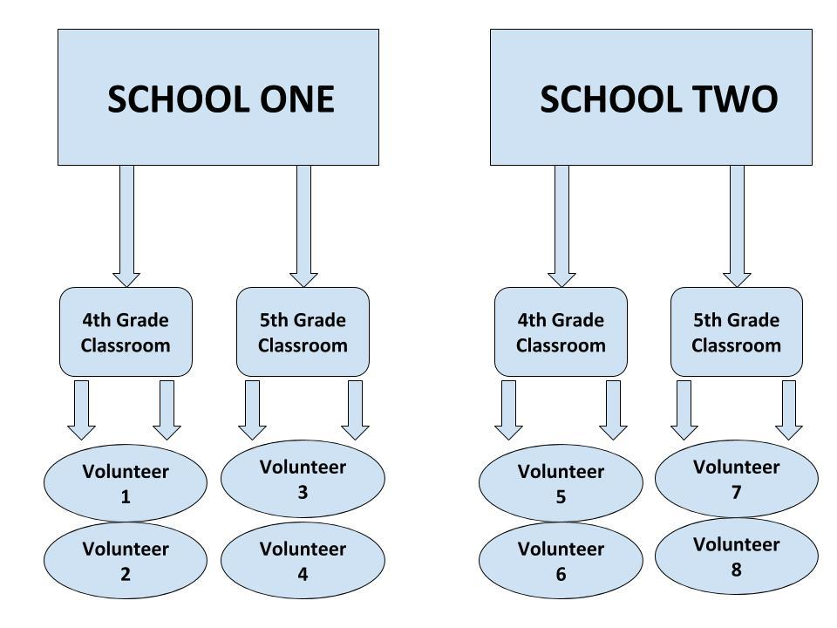
Harvard’s CIVICS program currently includes 20-25 teacher volunteers. By focusing on a smaller scale for our first year, we are prioritizing quality over quantity for our program. We understand that every student requires a degree of individualization in their schooling experience. By focusing on a small number of classrooms for our first year, our volunteers can develop genuine relationships with students in order to effectively meet their needs.
Our goal is to create a solid foundation of passionate, dedicated volunteers, which can only be done so by prioritizing high standards. The following personal teaching and public speaking skills will be emphasized for our volunteers:
∙ How to structure and deliver a lesson with a concrete outline that students can follow
∙ How to speak slowly and clearly with frequent repetition
∙ How to control a classroom by establishing clear expectations for the outset, as well as through techniques like “cold-calling”
∙ How to control body language to convey authority and eliminate nervousness
∙ How to integrate videos and audio recordings into lessons and what sorts of questions / follow-up to ask to ensure class wide comprehension
∙ How to integrate skits, games, motion-games, and other “student-volunteer” activities
∙ How to prepare a lesson in advance with a co-teacher
Because Civics teachers work in pairs, planning and executing each lesson with a teammate, we hope to foster a collaborative environment. Teaching a relatively small number of students with a partner requires precise coordination and control to avoid redundancy. It also requires self-moderation and sensitivity to ensure that one person does not dominate another, as both teachers have equal status. We hope that our members will learn how to operate more effectively as a team – with their partner, with their co-teacher in the classroom, or with the larger Civics leadership team and community as a whole, especially if they serve as an officer.

Interview Process

UNC-Chapel Hill has a multitude of student organization across campus. Many of these organizations pertain to government or education, making them serve as common-sense partners for our program to work with. The following groups will be contacted to gauge their interest in partnering with Civics in the Triangle to recruit teacher volunteers:
INSPIRE- A volunteer placement organization that helps UNC students get involved in classrooms spanning a variety of different subjects within the local Chapel Hill and Carrboro public schools system. The club prides itself on its flexibility, adhering to all prospective student's schedules, allowing students to find a perfect time to tutor that fits right into their day. It has 41 members on the UNC student website roster.
Contact: Trexler, Paige Emily [:paigetre@live.unc.edu]
Helping Youth by Providing Enrichment (HYPE): Campus Y program that provides social, cultural and educational experiences for K-5 students at underserved community centers throughout the Chapel Hill-Carrboro area. UNC students serve these centers by acting as both tutors and mentors. In addition to HYPE’s role as tutors, they seek to inform their members and the university as a whole about educational disparities still present today through interactive discussions and workshops.
Contact: [:hype.campusy@gmail.com]
UNC Tarheel Outreach Program: Program that plans for several NC public schools to visit campus in the spring each year. While on campus, students watch different performances from student organizations, listen to speakers from admission or multi-cultural affairs, participate in a lesson with a professor and experience real campus food at Ram’s Head dining hall. Since 2009, TOP has brought over 500 students to campus from five different counties.
Contact: Barefoot, Willow Ky [:willowky@live.unc.edu]
Students for Education Reform UNC: SFER UNC develops college students into grassroots community organizers for educational justice. It works to ensure a future where every child has an excellent education. As part of a national network of college students, SFER UNC advocates for positive policy change at the local and state levels.
Contact: Macmillan, Dory Gellins [:dorymac@live.unc.edu]
Movement of Youth at UNC-Chapel Hill: College students apply annually to become mentors and friends for middle and high school students in the Movement of Youth program. These close, year-long relationship provide participants with access to a scholar who offers knowledge about how to successfully apply to and excel in college. The goal is to promote the academic achievement of our participants, motivating them to complete high school and then pursue higher education. The program offers activities that support these goals and the relationships between mentors and mentees.
Contact: Curenton, Tonesha [:tonesha@live.unc.edu]
Splash UNC: Splash UNC aims to expand the academic horizons of high school students through a day of fun classes taught by undergraduates and graduate students. Emphasizing the passion and enthusiasm of our student teachers, we hope to encourage young adults from the Triangle region and beyond to explore their interests and engage their curiosities, and in doing so, develop a genuine love of learning.
Contact: Springman, Paige [:paigess@live.unc.edu]
These organizations are a starting point for increasing awareness about the new Civics in the Triangle program. Because this is a nascent organization, we aim to reach out to as many different partners as possible in order to attract the best talent.
The selection process for choosing UNC students to volunteer in the classrooms is modeled after Harvard’s CIVICS program. We anticipate that there will be a generous amount of interest in the program, but we want to ensure that the quality of the applicants is prioritized. For this reason, we will only select eight volunteers who have had experience working with children.
The following questions will be asked in the interview process:
1. Why are you interested in Civics? Of all the teaching programs at UNC-Chapel Hill, why does this one excite you?
2. What is your past experience working with children or teaching, or if you have no prior experience, what activities have you pursued which might be useful for Civics? Note that Civics teachers work in pairs; can you also describe an experience in which you overcame a challenge with a partner?
3. Please deliver a mock-lesson of 5 minutes on any topic of your choice; feel free to use props and any materials you see fit, but no powerpoints please! Ensure that your lesson uses step-by-step instructions and that you convey each stage clearly before proceeding to the next and ask comprehension questions along the way.

After the eight volunteers are finalized, we aim to work with Julie Hennis, Coordinator of Volunteers & Partners, in order to integrate them into the schools.

Program Structure
Leadership Team
Civics in the Triangle is led by one Program Chair, Lucy Russell, who oversees the management of the program. The Chair selects three sub-chairs, each responsible for different administrative aspects of the program. Collectively, these four chairs comprise the CIVICS leadership team, which strives to develop the initial program and facilitate its growth. Although all four are responsible for different tasks, the progress of each team member is tracked by the other team members, who are required to offer feedback on their peers’ projects. The descriptions of the positions may evolve as the program grows.

Descriptions:
The Civics Program Chair primarily handles both the budget and program integration with the IOP community while representing Civics on the IOP Student Advisory Committee. The Chair also organizes classroom scheduling logistics, recruits and interviews new volunteers, runs all-hands meetings every semester, and manages the three other sub-chairs of the leadership team.
∙ A Teacher Development Chair who is responsible for reaching out to potential teaching partners at UNC, refining our curriculum, improving the volunteer teacher training process, and collecting feedback from CIVICS members and public school teachers about our performance.
Purpose: This Chair will focus on adjusting the curriculum for the 2017-2018 School Year according to feedback from volunteers and teachers. Since this will be a new curriculum, it is anticipated that there will be lots of room for growth and improvement after its initial implementation. This role requires flexibility and innovation.
∙ A Community Chair who organizes new member induction, socials, and community dinners. The Community Chair also plays a crucial role in researching the various neighborhoods and districts we work in, collecting vital information and briefing our volunteers about the classrooms they assist.
Purpose: This Chair will foster a welcoming environment for all students and volunteers involved in Civics. The Chair will ensure that all volunteers feel a sense of comradery with one another, as well as a sense of community within the schools where they work. The second goal is to engage our volunteers with the families in the Chapel Hill/Carrboro community. By collecting information about the schools and their surrounding communities, the Chair will be able to give volunteers context about the students and their families, forging a close bond. This Chair will be instrumental due to the need to address the diversity of the CHCSS school district. It will play a major role in providing information about the students in order to create lesson content that mirrors the rich community in terms of diversity.
∙ An Outreach Chair who publicizes the organization during recruitment, manages our section on the IOP website, and develops and maintains our social media presence.
Purpose: This Chair will make the outreach process efficient and effective in order to attract the most passionate volunteers. The process is streamlined when one person is solely responsible for publicizing our program on campus. This is especially important in the first year, as the IOP and its programs are not as well-known. This role is also important in order to ensure a steady presence on social media, increasing awareness about our program.

Partner Schools
The program aims to work with two elementary schools in the Chapel Hill/Carrboro area for the 2017-2018 school year, depending on the receptiveness of the Principals. Two elementary schools will ultimately be the final partners after initially reaching out in early July. The three potential schools were chosen due to proximity to campus and presence in the Chapel Hill-Carrboro school district. After contacting all three schools and determining which are the best fit for the program, two will be chosen.
By choosing only two schools, we will solidify relationships with their administrations before we expand the program to other ones. One would anticipate that it would be easier to increase the number of classrooms within these two schools rather than expanding to new schools. That would create a solid foundation in terms of administrative relationships to facilitate future growth.

Elementary School Options:

School  Principal  Principal Email  Phone  Fax  Address  Hours  Website  Distance | Estes Hills Elementary School  Drew Ware  dware@chccs.k12.nc.us  919-942-4753  919-969-2475  500 N. Estes Drive, Chapel Hill, NC 27514 Map  7:50am - 2:30pm (regular school day) | 2:30pm - 6:00pm (After-School)  http://ehes.chccs.k12.nc.us  2.6 miles (9 minute drive from UNC Peabody Hall)
School  Principal  Principal Email  Phone  Fax  Address  Hours  Website  Distance | Ephesus Elementary School  Victoria Creamer  vcreamer@chccs.k12.nc.us  919-929-8715  919-969-2366  1495 Ephesus Church Road, Chapel Hill, NC 27517 Map  7:50am - 2:30pm (regular school day) | 2:30pm - 6:00pm (After-School)  http://ees.chccs.k12.nc.us  2.6 miles (11 minute drive from UNC Peabody Hall)
School  Principal  Principal Email  Phone  Fax  Address  Hours  Website  Distance | Northside Elementary School  Coretta Sharpless  csharpless@chccs.k12.nc.us  919-918-2220  919-918-2210  350 Caldwell Street, Chapel Hill, NC 27516 Map  7:50am - 2:30pm (regular school day) | 2:30pm - 6:00pm (After-School)  http://nes.chccs.k12.nc.us  0.9 mile (5 minute drive from UNC Peabody Hall)

School  Principal  Principal Email  Phone  Fax  Address  Hours  Website  Distance | Glenwood Elementary School  Katie Caggia  kcaggia@chccs.k12.nc.us  919-968-3473  919-969-2387  2 Prestwick Road, Chapel Hill, NC 27517 Map  7:50am - 2:30pm (regular school day) | 2:30pm - 6:00pm (After-School)  http://ges.chccs.k12.nc.us  2.1 miles (8 minute drive from UNC Peabody Hall)

Program Timeline
Our primary plan of action is to solidify partnerships with two elementary schools in the CHCSS district and allow them to give feedback about the curriculum. We also plan to work with one high school in Wake County through our burgeoning partnership with First Vote NC.
  - Our goal is to work with First Vote NC to send volunteers into a Wake County high school to teach two lessons in late September/early October. Then, we will start our four-week pilot program in the CHCSS elementary schools in late October/early November. This prefaces the eight-week program we plan to implement into the elementary schools in the Spring. We will have a dual partnership that allows us to work with a wide age range and branch out into schools around the Triangle, not exclusively with just Chapel Hill/Carrboro schools.
  - The Civics Program Chair reached out to the new CHCSS elementary school director (Dr. Watson-Grant) as soon as the position was filled. Then, after giving feedback about the program and its blueprint, Dr. Watson-Grant will proceed to contact individual school principals to gauge their interest in the program. This will be completed by mid-August. The next step is subject to change, depending on what the Principals deem is best.
  - After we have narrowed it down to two schools, the Principals will reach out to all Social Studies teachers for 4th and 5th grades to measure their initial interest. An email will be sent that contains a program description, as well as the curriculum. Also, a succinct one-pager that highlights how it will help teachers in will be included (emphasizing the collaborative nature of the program along with the ties to literacy standards). In the email that will be sent out to the applicable teachers, a Google form will be included that gathers information about their level of interest, their availability, etc. This will provide input for the Co-Chairs in order to adjust the program if needed. Then, after seeing how receptive the teachers are, we will make individual visits with the prospective teacher partners in August/early September.
  - We aim to spend the first three weeks of school advertising the program and garnering as much interest as possible on campus in order to have a talented applicant pool. Our Outreach Chair, Deja, has created an action plan to market the program. The goal is to individually reach out to students, student organizations and departments that pertain to Civics’ mission, then encourage them to apply with the IOP Application. They will be instructed to indicate their interest in the Civics program, specifically, so that we can arrange for the next step of membership.
  - The Institute of Politics Application closes on Friday, September 8th. The following week, Civics will coordinate interview times with all IOP applicants who indicated interest in our program. The weekend of Friday, September 15th-Saturday, September 16th will be used to interview all applicants. The interview process is included in the Official Documents folder.
  - On September 17th, we will finalize the eight volunteers who will be Civics Teachers for the Fall Semester. This will allow for the two First Vote NC lessons to begin in early/mid-October, allowing for time to train the volunteers and allow them to familiarize themselves with the lessons.
  - First Vote NC launches their election simulation platform on Tuesday, October 24th. Ideally, we would have our volunteers in the classrooms once a week for two weeks before it launches. We plan on having teacher training (run by First Vote) the week of September 25th. Tentatively, we are planning to have our volunteers go to Wake County the weeks of Monday, October 2nd and Monday, October 9th. The following week (October 16th) is our Fall Break, so we are avoiding scheduling any lessons then.
  - In the meantime after Fall Break and before getting into the CHCCS classrooms, we plan to have additional weekly programming to keep the volunteers engaged. Our Community Chair is planning team bonding activities, and we plan to have several teacher trainings with the Fall Curriculum. Also, the team members can have workshops to give feedback on the Spring Curriculum.
  - With this timeline, the four-week Fall Curriculum would begin the last week in October and end the first week in December. UNC-Chapel Hill’s Fall Break and Thanksgiving Break are accounted for with this schedule. The fall semester would consist of the weeks of: 10/30, 11/6, 11/13, 11/27. This schedule also accommodates the exam schedule for UNC-Chapel Hill, which begins December 8th, as well as all academic breaks.
Important General Dates Fall 2017:
• Thursday, August 17: Meet with Dr. Watson-Grant about CHCSS
• Tuesday, August 22: First day of class for UNC-Chapel Hill students
• Monday, August 28: First day of class for Chapel Hill/Carrboro public schools
•Late August/Early September: Recruitment action plan for Civics teachers
•Friday, September 8: IOP Application Closes
• Friday, September 15-17: Civics volunteer interviews and decisions (17th)
• Monday, September 18: Civics full team meeting
• Saturday, September 22: First Vote Teacher Training for UNC Civics volunteers
• Week of Monday, October 2: First lesson in Wake County high school
• Week of Monday, October 9: Second lesson in Wake County high school
• Week of Monday, October 23: Team bonding exercise
• Week of Monday, October 30: First lesson in Chapel Hill/Carrboro Schools
• Week of Monday, November 6: Second lesson in CHCCS
• Week of Monday, November 13: Third lesson in CHCCS
• Week of Monday, November 27: Fourth & final lesson in CHCCS
•Late-November: All members of the Civics Leadership Team have conducted mid-semester feedback sessions with Program Chair

