Copyright Permission Form
For Copyright Holders Granting Permission to UNC

Author: North Carolina Association of Electric Cooperatives Title (if any): Rural Electrification oral history project Description (e.g. article/slides): digitized audio recordings of oral history interviews (mp3s) Date Created: 1984 Number of items: 33 Publication data (if published):

I understand and assert the following:

- Grant of Permission: I grant to the University of North Carolina at Chapel Hill a perpetual, royalty free, non-exclusive permission to use, reproduce, distribute, publicly perform, publicly display, and permit others to use, reproduce, distribute, publicly perform, and publicly display the materials described above (the "Materials"). Materials will be added to the Southern Oral History Program Collection (#04007) in the Southern Historical Collection at Wilson Library at UNC-Chapel Hill, where they will be made available for use consistent with the University’s mission, including but not limited to use whole or in part in exhibitions, public programs, documentary films, radio broadcasts, and publications in all formats and media, including on the Internet. See examples here: www.lib.unc.edu/dc/sohp/.
- Authority and Third-Party Content: I represent that, except where I indicate otherwise, I, to the best of my knowledge, hold the copyright or other proprietary right in the Materials or that the Materials are in the public domain, and that I have authority to grant this permission.

Rights Owner’s Name: Jane Forehand, North Carolina Association of Electric Cooperatives

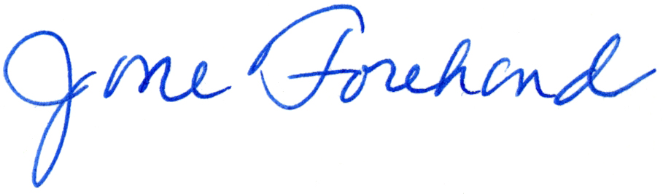
Signed:

Date: 09-26-2016

Address: 3400 Sumner Blvd., Raleigh NC 27616

Phone: 919-875-3067

Email: jane.forehand@ncemcs.com

Please fill in the appropriate blanks. Sign the form where indicated and email or fax or mail a copy to:

Email: jnvos@email.unc.edu
Address: 410 East Franklin St, CB #9127
Chapel Hill, NC
27599-9127
Unit: Southern Oral History Program
Attention: Jaycie Vos

