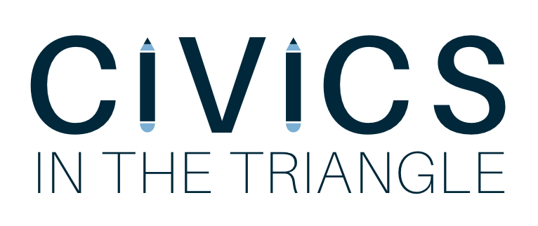

“Quote from Lucy? About importance of this organization”

Program Description
Civics in the Triangle is a newly formed organization under UNC’s Institute of Politics. The program aims to inspire civic engagement in youth by placing motivated UNC-Chapel Hill undergraduates in elementary school classrooms in the local community, teaching civics and government classes.
The program will work with two public schools in the Chapel Hill/Carrboro area during the 2017-2018 school year. We are tailoring our program to meet the needs of 4th and 5th grade classrooms over an 8-week long period every Fall and Spring. The program will recruit 8-10 volunteers to work in pairs to teach course material related to civic engagement.
How to mention Harvard.. “through the success of Harvard’s program.. we were inspired to create our own organization modeled after theirs”? Not sure.
Need a hook about why we started this. Compelling story/reason!
Curriculum
We want to provide lessons that are relevant, interactive, and engaging for our students. Our curriculum will be organized, easy to teach, and consistent between different classrooms.
The three pillars of our curriculum are: civics, American history, and government. At the start of the program, there will be a preliminary assessment to gauge where the students’ knowledge of history and government; this can be used to compare with a final assessment to measure how much students learned. There will be separate curriculums for the 4th and 5th grades, adjusted accordingly for their educational levels and maturity. The lessons will supplement the North Carolina 4th and 5th grade Social Studies courses with the introduction of additional dynamic instruction strategies to assist teachers.
In order to draft these lessons, we have partnered with Carolina K-12 (formerly the NC Civic Education Consortium), a program of UNC-Chapel Hill’s Carolina Public Humanities that works to extend the resources of the University to North Carolina’s K-12 educators. Another resource, iCivics, founded by Justice O’Connor, provides teachers with well-written, inventive, and free online resources online to enhance their practice and inspire their classrooms.
Deadlines
September ?- Civics volunteer applications open
September ?- Civics volunteer applications close
September 15-17- Civics volunteer interviews and decisions
September 18- CIVICS mandatory team meeting
September 22- Teacher training for UNC students

