- School system
  - Structure
  - Zoning

Lesson Objectives
- Students can describe the basic structure of the school system
- Understand a brief history of the American education system
- Understand the goals of the school system, and why we teach the things we do

Guiding Questions
- What is some historical context for the modern school system?
- What are some of the goals of the modern school system
- What is the basic structure of the school system?
- How have the materials for the school system changed throughout the years?

Lesson Plan
- History
  - Explain to the students that he first schools opened in the 1600s in the original thirteen colonies
    - One room schoolhouses were the norm
    - Very heavy Christian religious base
  - By 1870, all states had free public elementary schools
  - By 1900, education was seen as necessary for developing intelligent citizens, and the modern school system began to form
  - There have been problems with the school system
    - Until the 1960s, many schools were segregated by race
      - “Separate but equal”
      - In reality, separate but not equal
    - School system today still working to establish equal educational opportunities for all students
- Modern goals of public school system
  - Ask the students what types of goals they think the American school system has? Can they identify why they have been going to school since they were 5. Record the students answers on the board
  - Once the students have brainstormed, make sure that these three are mentioned, either by you or the students (not necessarily word for word, just general idea).
    - Deliver equality to all American citizens
    - K-12 required for all American children
    - Create well rounded individuals who have creative, critical thinking and problem solving skills

- Structure
  - Tell the students that the school system is a complicated, multi-level organization, kind of like the American government that you have talked about before. Give the students a basic overview so they understand the structure.
  - Headed up by the state
    - Local and federal input also received
  - Curriculum, teaching, employment, and other policies are set through locally elected school boards
  - Learning standards are set up by the state
  - Hierarchy in schools/school systems
    - Teachers → administration → school board → superintendent
- Alternative forms of education
  - Explain that there is more than one way to get an education. Ask the students if they can think of any other ways students might be receive an education.
    - Homeschool, charter school, private school, religious school

Civics “Primer” Activity
- Pass out copies/project a picture of primer from the 1600s, 1800s, and today
  - Ask them what types of similarities and differences the see between all three
  - Ask them what types of ways they learned how to read
    - Do they think they are similar or different from the ways children in earlier times learned?

1800-1850
  - 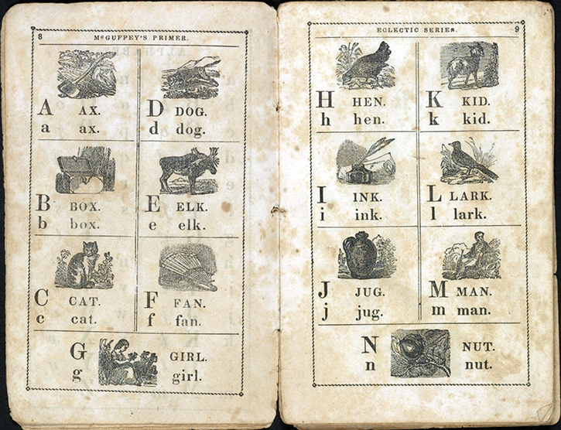
1600s
  - 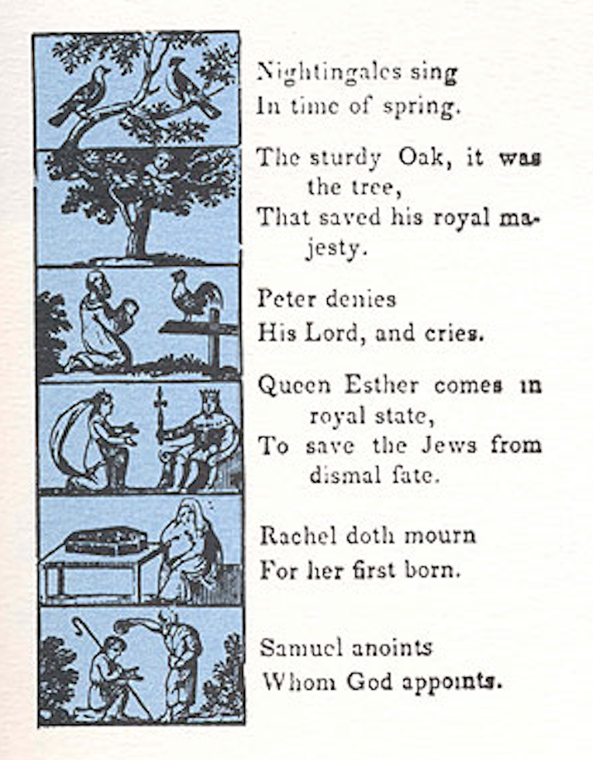
  - Hand out pieces of blank white paper to each student. Assign each child a letter of the alphabet (you may be a few short, that’s okay). Explain to them that they are going to create a modern day “primer” for the alphabet. Each student should come up with a word that begins with the letter they were assigned. If possible, relate the words back to previous Civics lessons (ideas, words, people, concepts you have taught them!). This might be kinda hard for some of the letters, but work with the students They can then write a short sentence, rhyme, or poem, similar to the ones they saw on the primers, along with illustrating the page. Encourage the students to use bright colors and be creative! Once all students have completed their drawings, collect them. Explain to the students that these pages will be bound into a book and brought back to the classroom for the students to see.

