Abstract

1. Sorting Code: “Exploratory Research on Nanotechnology” 2001-STAR-K1

2. Title: Molecular Self Assembly in Supercritical Carbon Dioxide

for Environmentally Friendly Isolation of Nanoscale

Structures/Materials
3. Investigators: Joseph M. DeSimone, Principal Investigator
4. Institution: University of North Carolina at Chapel Hill
5. Project Period: 11/01/2001 – 11/01/2004
6. Project Cost: $452,005.00
7. Project Summary:
Objectives: Surfactants are crucial to the development of a more energy efficient solvent technology platform (namely liquid and supercritical carbon dioxide) than the aqueous, volatile organic solvents, chlorofluorocarbons and other noxious solvents currently used by the manufacturing and service industries. Our group (along with Johnston at UT-Austin, Beckman at University of Pittsburgh, and Eastoe at University of Bristol) has been at the forefront on establishing design criteria for molecularly engineered surfactants that can stabilize and disperse otherwise insoluble matter into a CO₂ continuous phase. Given our expertise in the design and synthesis of polymeric surfactants for CO₂, we propose to develop novel small molecule surfactants for CO₂.
Approach:
Expected Results: This will be the first such CO₂ studies of this class of surfactants for use in CO₂. Synthetic flexibility is available as chain characteristics (such as length, hydrocarbon branching, or degree of fluorination) and spacer length/structure can be varied. This allows for systematic evaluation of surfactant structure-activity relationships in dense CO₂ to an extent far beyond what has been reported to date, and will allow for solution properties to be optimized through subtle synthetic variations. The gemini surfactant in CO₂ systems comprise a unique coupling of two rapidly growing areas of small-molecule surfactants - geminis representing an important new direction in surfactant structure, and dense CO₂ representing an increasingly important solvent for self-assembling systems. Hybrid hydrocarbon/fluorocarbon structures may be important in two regards: (1) enhanced stabilization of discrete microemulsion droplets through lessened chain-chain interactions compared to “fully” hydrocarbon-chained or fluorocarbon-chained surfactants, and, (2) reduced cost compared to “fully” fluorinated surfactants. Biocompatibility and toxicity appear to be very promising for morpholinophosphate fluorosurfactants as they are already being used in neonatal care and in blood substitute emulsions. Thus, CO₂-fluorosurfactant systems comprising this class should be environmentally and biologically benign.

8. Supplemental Keywords: micelle self-assembly and drug delivery systems

Molecular Self Assembly in Supercritical Carbon Dioxide for Environmentally Friendly Isolation of Nanoscale Structures/Materials

Introduction
The unique chemical and physical characteristics of nano-organized systems are expected to be a source of flourishing opportunities for applications in science and technology. The self-assembly of surfactants into association colloids falls under the realm of nano-organized systems and has long been an attractive field of study.¹ While efforts have predominantly concentrated on self-assembly in water or organic solvents, a vibrant field is currently in an area perhaps unanticipated by the early pioneers: self-assembly in compressible media, such as liquid and supercritical carbon dioxide (CO₂). The compressibility aspects of CO₂-based surfactant systems can be exploited to design molecules that can reversibly assemble or disassemble depending on the solvent quality which is a function of solvent density.
An increasing demand for environmentally friendly chemistry and processes supports a large part of the interest in CO₂. CO₂ is a nontoxic, inexpensive, naturally occurring, abundantly available solvent with tunable properties. Small changes in temperature or pressure enable CO₂ to exhibit changes in solvent density without altering solvent composition. Furthermore, CO₂ has an easily accessible critical point with a T_{c} of 31.1 ºC and a P_{c} of 73.8 bar. For all of the reasons outlined above, CO₂ would seem to be an ideal emerging technology platform to mitigate or even eliminate many of the environmentally harmful problems associated with conventional solvents. However, two significant barriers inhibit this vision ⎯ the poor solvency of CO₂ (hence the need to design surfactants for CO₂) and the lack of understanding regarding the usefulness of CO₂ as a reaction or processing medium. Compressed CO₂ is nonpolar, possesses a low dielectric constant, and does not strongly engage in van der Waals interactions. It is therefore a poor solvent for many highly polar and high molecular weight materials. Our group (along with Johnston at UT-Austin, Beckman at University of Pittsburgh, and Eastoe at University of Bristol) has been at the forefront on establishing design criteria for molecularly engineered surfactants that can stabilize and disperse otherwise insoluble matter into a CO₂ continuous phase. In CO₂, the solubility characteristics of compounds can be classified from a CO₂-centric viewpoint as either “CO₂-philic” or “CO₂-phobic”. “CO₂-phobic” compounds can be further subdivided into hydrophilic and lipophilic or oleophilic. With this being understood, one can now molecularly engineer interfacially active compounds through the judicious catenation of CO₂-philic segments with CO₂-phobic segments. By altering the molecular weight, composition, temperature and pressure, amphilies of this nature enhance the efficacy of liquid and supercritical CO₂ to dissolve or emulsify highly polar and highly lipophilic, oligomeric, and polymeric compounds. The recent technological breakthroughs in surfactant design could make dense carbon dioxide the most commonly used solvent in the twenty-first century. The continued development of novel surfactants will, however, be key to extending the growing list of applications for CO₂ solvent-based processes.
Fundamental understanding of amphiphilic self-assembly in CO₂ is very much a work in progress. This is well-illustrated by the fact that while fluorocarbon and siloxane moieties are widely-used for their tendency to prefer a CO₂ rich environment, there is no consensus on why they exhibit such favorable solubilities in the solvent. Indeed, CO₂ has recently been shown by Eastoe to dissolve branched hydrocarbon-based surfactants² ⎯ work that build upon McHugh’s earlier observations that poly(vinyl acetate) shows much high solubility in CO₂ (but still at too high of a pressure to be useful) than its isomer poly(methyl acrylates).³ Self-assembly of amphiphiles is controlled by a balance of cooperative and competing factors.⁴ A fundamental aspect is the interplay between the amphiphile and solvent. In order to disperse in solution, a portion of the amphiphile must preferably dissolve in the bulk solvent, while another portion is of low solubility. Solute-solute, solvent-solvent, and solute-solvent enthalpic and entropic interactions all influence solubility. In oversimplified terms, to dissolve, a material must favor mixing with the solvent rather than remain associated in a phase-separated state. For dense CO₂, this is a formidable problem given its weak solvency; consequently, the choice and design of amphiphiles for CO₂ applications is not a trivial issue.
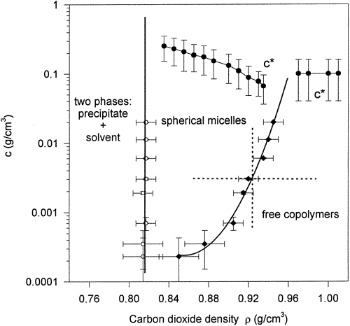
We have previously confirmed the phenomena of a critical micelle concentration in a study of poly(vinyl acetate) (PVAC)-b-poly(1,1,2,2-tetrahydroperfluorooctyl acrylate) (PTAN).⁵ Three regions were observed on the phase diagram of the copolymer: (i) two-phase region at low CO₂ density; (ii) solutions of spherical micelles at intermediate CO₂ densities; (iii) solutions of unimers (individual copolymer chains) at high CO₂ densities. The aggregation number (the number of copolymer chains in a micelle) decreased with an increasing density of supercritical CO₂ in region (ii). An increase of the CO₂ density corresponds to the improvement of solvent quality for both blocks of the copolymer (PVAC and PTAN). The hydrodynamic radii of micelles and unimer were measured using dynamic light scattering in regions (ii) and (iii), respectively. This light-scattering study is the first one reporting a solvent density-induced transition, a critical micelle density, between spherical micelles at lower supercritical CO₂ density and unimers at higher CO₂ density. The light-scattering technique appears to be a very powerful tool for the analysis of carbon dioxide density-induced micellization transition (CMD). This phenomenon is unique to supercritical fluids and demonstrates a convenient control over the polymer solubility.
Figure 1. Phase diagram for PVAC-b-PTAN copolymer in CO₂.
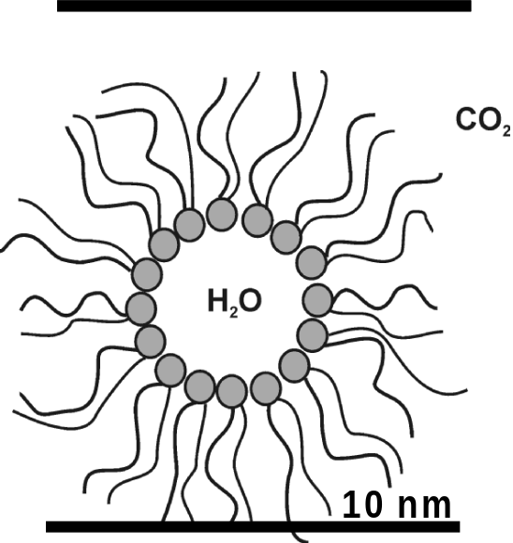
While polymeric surfactants for synthesis and reversible self-assembly in CO₂ have advanced rapidly in the past few years, small molecule surfactants for CO₂ applications have not been fully exploited. Over the last six years, a lot of attention has been given to surfactant stabilized water dispersed into a continuous CO₂ phase.⁵⁻¹⁶ “Water-in-carbon dioxide” (W/C) microemulsions allow for solutions having dual solubility capabilities – the means to dissolve highly polar materials within a greater CO₂ phase, and to render water-insoluble molecules accessible to water-bound components (e.g. enzymes) through interfacial exchange. While similar “water-in-oil” (W/O) microemulsions have been known for many years, they usually contain petroleum-based solvents (e.g. heptane) as the oil phase. Liquid and supercritical CO₂ provide cleaner options to such solvents in addition to the benefit of adjustable solvent quality. Colloidal systems for various processes in CO₂ have been developed and noteable achievements include the formation and detection of reverse micelles,⁶ emulsions and microemulsions,⁷⁻¹⁹ enzyme-encapsulating water pools,^{13,19} as well as metal chelation,⁸ small-scale synthesis in emulsions and microemulsions,^{17,18} nanoparticle formation,²⁰ and the dry cleaning of garments.²¹ The most successful systems thus far, however, have involved "potentially toxic" perfluoropolyether (PFPE) carboxylates.^{22, 23} In addition, perfluorinated octyl sulfonates (PFOS) have also been studied for use in CO₂, but such surfactants are in disfavor because of their persistence in the environment. Hence, our focus on branched hydrocarbons as well as on telomer-based fluorcarbon tails appear at this stage to be quite different in their bioaccumulation characteristics relative to PFOS moieties. To more fully exploit the capacity of CO₂ as a "green-friendly" solvent for diverse purposes, such as non-toxic cleaning or processing drugs and materials for pharmaceutical or medicinal purposes, it is imperative to develop systems based upon biocompatible, low-toxicity fluorosurfactants.

Preliminary Results
The vast potential of CO₂ as an environmentally clean, abundant, and tunable solvent is now being realized on a variety of fronts, including cleaning protocols, coatings, and polymer production and processing.¹ In order to take advantage of CO₂’s benefits, however, it is often necessary to confront an important limitation, namely its low capacity for solubilizing many materials, including water. One way this issue has been addressed is through the use of small-molecule surfactants that can self-assemble (micellize) and aid the dispersion of water-in-CO₂ (W/C) via the formation of nanometer-sized microemulsions.² Recent work has been carried out that has resulted in W/C microemulsions containing considerable water loadings, allowing for templated inorganic nanoparticle synthesis,³ organic reactions,⁴ and enzymatic conversions⁵ to take place within their water pools. These reports provide a tempting early glimpse into the types of nanoscale chemistries that are possible using CO₂.
Unfortnuately, only a handful of small-molecule surfactants have proven capable of self-assembly and water uptake in CO₂. The development of new CO₂-amenable surfactants is critical to continued progress in the fundamental understanding of these nanoscale systems, the successful implementation of new analytical techniques to study W/C solutions, improvement of solution performance and properties, and the expansion of useful applications. We have begun investigations into the viability of various classes of phosphorous-containing surfactants for CO₂. Our program involves components of synthesis, physical characterization, and application of the surfactants. Three examples of surfactant classes we have prepared and studied, including nonionic, zwitterionic, and anionic fluorosurfactants, are shown below.
Neutral surfactant 1 is one of a class of biocompatible fluorosurfactants known as morpholinophosphates, originally developed by Riess and Krafft for aqueous and fluorocarbon media.⁶ These surfactants, which can contain either two morpholine units and one fluorinated tail, or one morpholine unit and two fluorinated tails, possess very high solubilities in CO₂. Zwitterionic surfactant 2 belongs to the family of “gemini,” or dimeric surfactants that contain individual surfactant units covalently attached at some level (in this case, the headgroup region).⁷ In collaboration with the group of Prof. Fredric Menger of Emory University, we have found a number of these surfactants dissolve in supercritical CO₂, which is unusual given the ionic nature of the surfactants and the nonpolar nature of CO₂, and suggests surfactant aggregation. Anionic fluorosurfactant 3 was conceived in our laboratory and was found to have excellent capacity for dissolving water within CO₂ in the form of W/C microemulsions.

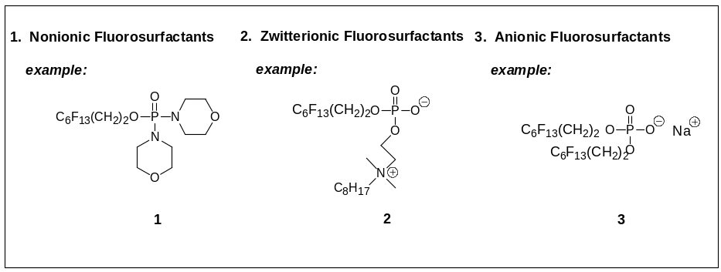
Two important points should be stated concerning our approach to surfactant design. First, the surfactants all contain a unit that aids in the surfactant’s dispersion in CO₂, a “CO₂-philic” tail group. In the above surfactants, the fluorinated chains serve in this capacity; other functionalities that are possible include siloxanes, polycarbonate ethers, and some highly branched hydrocarbons. Second, the surfactants have a modular design, where multiple and systematically-varied analogs can be prepared in high purity through straightforward syntheses. In this manner, surfactants can be screened for structure-property relationships, an approach we believe is necessary to better understand self-assembly of small molecule surfactants in CO₂ and create a wide range of surfactants with properties tailored to suit particular nanoscale applications.
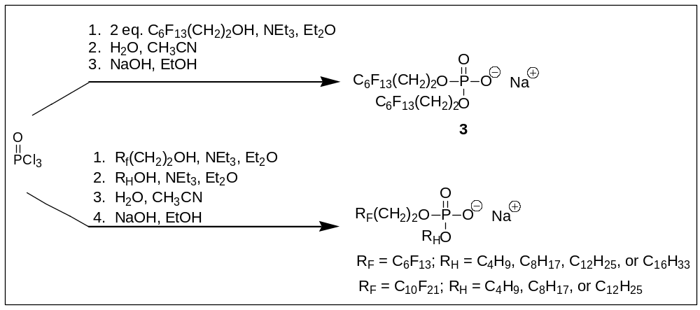
A successful demonstration of the impact of modular design on structure-property relationships is found in preliminary data on anionic phosphate fluorosurfactants developed in our laboratory. In the scheme below, similar synthetic pathways can yield difluoro-chain surfactant 3 as well as seven related hybrid surfactants that contain one fluorinated and one fully hydrocarbon chain, achieved by simply interchanging the starting materials.

Scheme I. Synthetic pathway to variety of surfactants proposed herein.

Despite possessing equivalent headgroup units, the surfactants displayed very different behaviors in CO₂, as borne out by microemulsion cloud point measurements of 2.5 wt.% surfactant solutions containing various amounts of added water (where W_{o} = water/surfactant
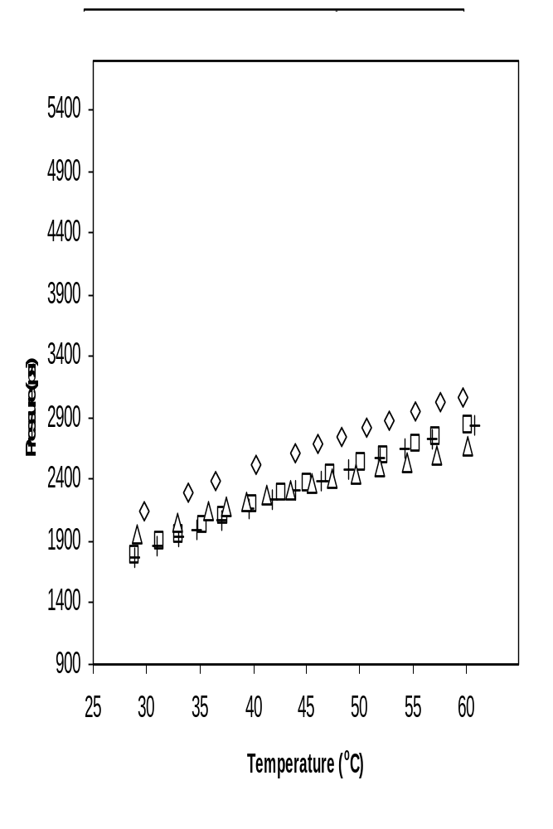
Figure y. Demonstration of water uptake by four different surfactants. In all cases 2.5 wt% of surfactant was dissolved in CO₂ and Wo implies moles of waer to moles of surfactant. the morphonlinophosphate fluorosurfactant developed in this proposal (figure indicates structure of particular surfactant utilized for the study).

molar ratio). In the graphs below, it is shown that for the R_{F} = C₁₀F₂₁ series, higher water loadings become possible with an increase of R_{H} chain length (where above the respective curves exists a transparent, homogeneous solution and below the curves exists a phase separated state). Compound 3, with two fluorinated chains, can also disperse water in CO₂, but has linear cloud point profiles that are much simpler that those of the hybrid surfactants. Thus, by changing surfactant structure, it is possible to access systems with varied phase behaviors, any of which may be useful in a particular CO₂ application (such as nanoparticle synthesis) that is to be carried out under specific conditions (i.e., pressure, temperature, high or low water loadings).

Specific Research Objectives
Given our expertise in the design and synthesis of polymeric surfactants for CO₂, we propose to expand on our preliminary small molecule surfactant work in two areas. First, we propose to continue to develop and characterize new surfactants capable of nano-organized self-assembly in CO₂. Our emphasis will be on determining and improving the solution properties of the surfactants utilizing light and small angle neutron scattering techniques as well as complete phase behavior diagrams. As we engage in this fine-tuning design process, promising surfactants will be prepared at reduced costs or from renewable resources and possess excellent solution properties in CO₂. The second area we propose to focus on in this proposal will be applying our current and future surfactant/CO₂ systems to existing or emerging nanoscale technologies, such as nanoparticle preparation via microemulsion polymerization and cleaning processes using rapid expansion of supercritical solvent (RESS) techniques

Approach
Of the surfactants that have been capable of self-assembly or microemulsion formation in CO₂, those with fluorinated tail units have been the most widely studied. It is not yet clear why fluorinated units disperse so well in CO₂, although possible reasons include low solute-solute interactions between fluorinated units due to their low cohesive energy density,⁸ and the existence of specific interactions between fluorine atoms and CO₂.⁹ Our approach thus far has been to include a fluorinated portion in the phosphorous-based surfactants; we plan to continue synthesis and study of fluorinated surfactants to optimize solution properties in CO₂ (e.g., water uptake capacity) through such structural variations as changing counterions and chain length combinations (as for surfactants 2).
It is important, however, to explore other possibilities regarding surfactant structure, in particular the use of less expensive, non-fluorous groups for dispersion into CO₂. As mentioned above, silicon-containing materials are CO₂-philic and have been used for polymeric surfactants. We have prepared ammonium-based cationic surfactants with polydimethylsiloxane tails and expect to incorporate them into other surfactant types. Beckman and coworkers have recently reported poly(ether-carbonate) copolymers that possess excellent solubility in CO₂ at moderate pressures.¹⁰ We are presently developing such materials for incorporation into surfactants such as the phosphates.

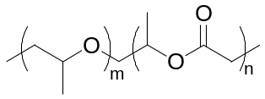
Eastoe et al. have recently reported sulfonate surfactants (analogs of Aerosol-OT) possessing tails with chain branching and tri-methylated tips that dissolve and micellize in CO₂.¹¹ Hydrocarbon based surfactants (such as, for instance, Aerosol-OT) usually possess very poor solubility in CO₂. It has been postulated that multi-methylated chain tips provide a steric barrier that repels approaching micelles from each other, thus stabilizing discrete aggregates in CO₂. We plan to synthesize analogous phosphate surfactants, using commercially available alcohols such as 2,4,4-trimethyl-1-pentanol. In addition, we will prepare surfactants from branched polyprenyl alcohols, which are derived from renewable, non-petroleum sources. Alcohols such as 3,7-dimethyl-octanol and gerianol are two alcohols that can be used. The anionic phosphate surfactants should be accessible via one or both of the synthetic pathways shown below; Strategy 2 is adapted from work published by Ourisson et al. on polyprenyl phsophates.¹²

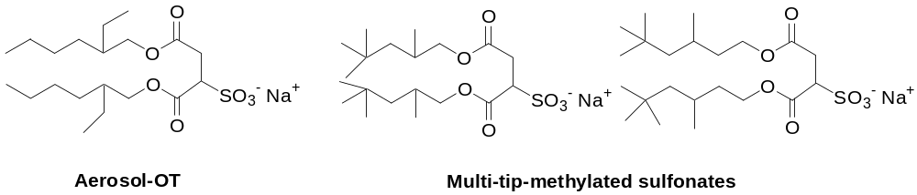
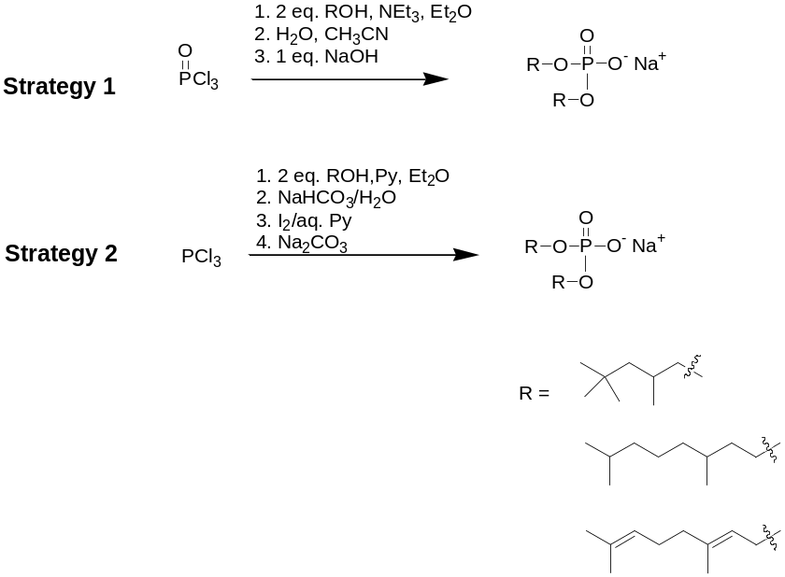

Once prepared, the CO₂ solution behavior of the new surfactants will be subject to analysis by a variety of means. Cloud point solubility studies (as shown above) of surfactants with and without additional solutes (e.g., water) will be carried out using a variable volume view cell as described in the literature.¹³ The resulting data provides valuable information regarding solution homogeneity, and maps out possible CO₂ temperature and pressures for carrying out applications. UV-Vis spectrometry of W/C microemulsions can confirm the presence of nanoscale water droplets, via dissolution and solvatochromatic shift evaluation of the CO₂-insoluble dye methyl orange. Below are spectra for methyl orange dispersed in W/C microemulsions of surfactant 3, referenced against methyl orange in pure water.
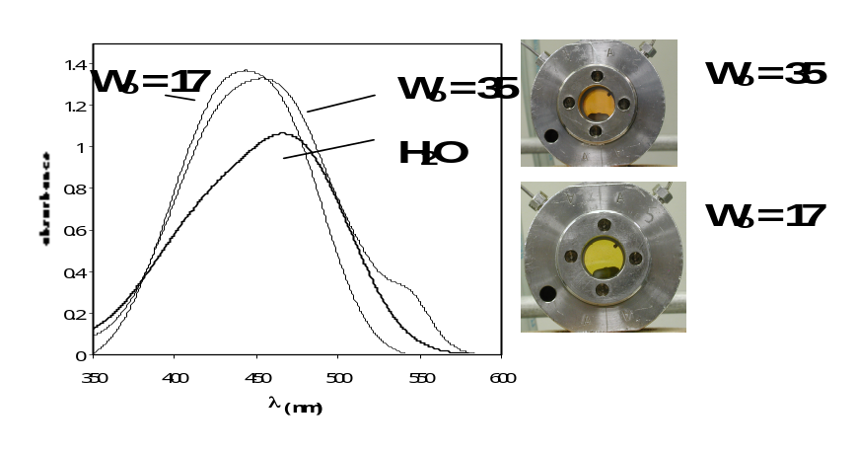
Figure 3. UV-Vis spectra of solutions containing 2.5 wt.% surfactant 2 and 0.05 mM methyl orange in CO₂, at water loadings of W_{o} = 17 and 35, along with the spectrum of methyl orange in pure water.. Corresponding photographs of solutions are to the right.

Scattering techniques provide extremely valuable information regarding the size and shape of nanoscale particles such as microemulsion droplets. We have designed and built a new high pressure cell for static and dynamic light scattering that allows for a wide continuous angle sweep. We also maintain collaborations that allow for small angle neutron scattering studies of our CO₂ systems. Our laboratory is also developing high pressure electrochemistry and nuclear magnetic resonance spectroscopy (NMR) methods for evaluation of diffusion within W/C microemulsions.
From the repertoire of surfactants we have already synthesized and characterized, we plan to explore novel applications (including nanoparticle preparation via microemulsion polymerization and cleaning processes using rapid expansion of supercritical solvent (RESS)) incorporating new small molecule branched hydrocarbon surfactants and telomer-based fluorosurfactants as they become synthetically available. The applications we propose are outlined in more detail below.

Formation of Polymer Nanoparticles
The ability to stabilize aqueous droplets in CO₂ provides an opportunity for a wide range of applications such as separations, chemical reactions, and synthesis of particulate materials. The restricted but adequately large water core of the microemulsion can be well suited for the synthesis of macromolecular compounds that display novel physical properties. N-isopropyl acrylamide (NIPAM), and hydroxypropyl acrylate (HPA), 2-hydroxyethyl methacrylate (HEMA), and hydroxypropyl methacrylate (HPMA) are all water-soluble monomers that produce water-insoluble polymers (see Figure 11 for structures).^{16, 17} We propose to conduct polymerizations of these monomers inside the water pool of W/C microemulsion formed by the fluorosurfactants discussed in this proposal. The core will be crosslinked using a water soluble monomer N,N-methylene bisacrylamide (MBA). In general, all the reagents will be added to a high-pressure cell and subsequently filled with CO₂. We anticipate running the reaction at ~1800 psi and 65 °C. At the end of the reaction, CO₂ will be vented and the resulting particles will be collected by sweeping to CO2 to rid of surfactant. The particles will be examined by SEM, TEM and thermal analyses.

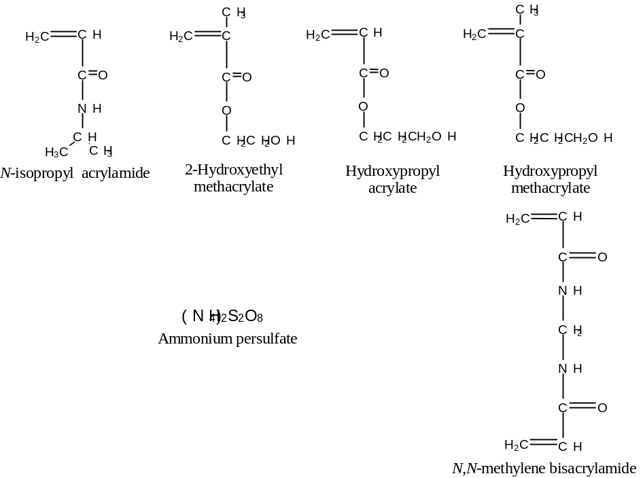

Figure 11: Structures of monomers, crosslinker and initiator.

Formation of DNA-Loaded Microspheres
We propose to fabricate polymeric microspheres or microparticles loaded with pharmaceuticals. Potential applications could be realized in controlled drug delivery, a genetic term describing a wide range of systems aimed at providing temporal or spatial control of the release of therapeutic drugs in the body. Controlled drug-release can minimize both the variations in the drug’s concentration in the body and the quantity and frequency of drug dosages, thereby improving therapeutic action by enhancing the drug’s effectiveness. One method of administering controlled drug formulation is through injection of polymer-drug microspheres and microparticles (<100 um). In most applications, the polymer is degraded by body fluids over time to non-toxic products.
Microemulsion polymerization has been investigated as a method to produce monodisperse polymeric nanogels with the potential for desirable in vivo solubility, stability, safety, and pharmacokinetic properties. The chemical and physical properties of the nanogels formed by inverse microemulsion polymerization can be controlled by the selection and design of monomer and crosslinking species suitable for use in microemulsion polymerization. Since particle growth will occur within the water droplets, the size of the water core can be used to control the particle dimensions. DNA can be incorporated into the matrix of the nanogels by dissolving oligonucleotides into the aqueous phase of the inverse microemulsion prior to polymerization.
Current techniques for producing polymer-drug matrices involve dissolution of the polymer and drug in a common organic solvent. Preliminary attempts in our laboratory to form these nanogels in organic solvents (i.e oils like heptane, hexane, etc.) have been successful. The nanogels formed in the organic based inverse microemulsion were isolated by extraction and dialysis to remove surfactant and organic solvent. Light scattering and transmission electron microscopy analysis of these nanogels revealed that a monodisperse population of 50 nanometer nanogels was obtained.

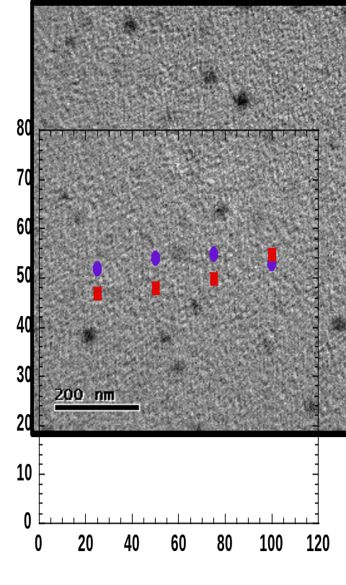
From our preliminary screening, w/c microemulsions form with several fluorosurfactants outlined in this proposal. We propose to use w/c microemulsions as a compartmentalized media to grow DNA-loaded microspheres. A series of inverse microemulsions containing the monomers 2-hydroxyethylacrylate, poly(ethylene glycol)-diacrylate, or 2-acryloxyethyltri-methylammonium chloride will be polymerized and crosslinked. A fluorescein labeled oligonucleotide will also be dissolved in the aqueous phase. We anticipate using similar methodology as in the water-in-oil-microemulsion to isolate and then characterize the nanogels formed in CO₂ utilizing the small molecule flourosurfactants that have been outlined in this proposal. The advantages of forming the nanogels in CO₂ include the absence of organic solvents that need to be removed before in vivo use as well as high temperatures that may affect the stability of the DNA. In addition, the surfactants utilized could prove be biocaptible (tests will need to be conducted to confirm this point) and thus lend the development of DNA-loaded nanogels in CO₂ as a solvent-free single step process.
Figure 9. TEM Images of Non-ionic Nanogels prepared using 25% crosslinker. TEM prepared by staining sample with 1% Phosphotunstic acid. (top). Dynmaic llight scattering results (bottom)

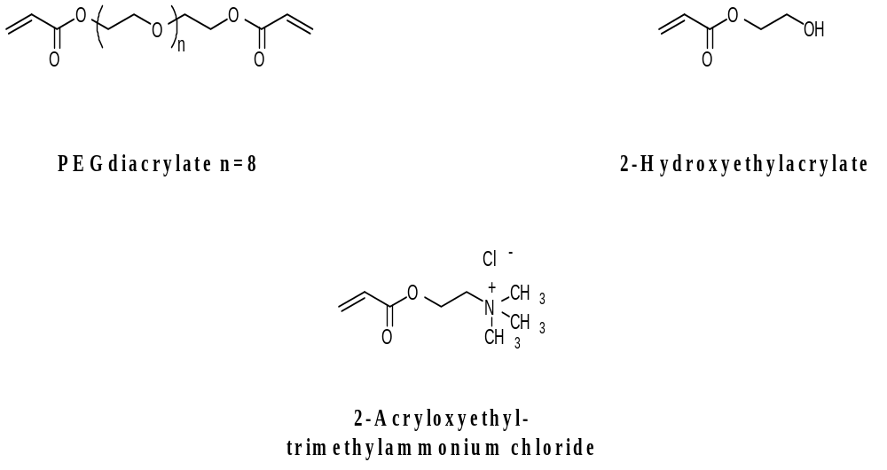
Figure 10. Monomers proposed for polymerization inside W/C microemulsions.

Surface Preparation and Cleaning Utilizing W/C Microemulsions in RESS Spraying Technique
Abrasive blast cleaning has been used in a variety of applications including surface cleaning and preparation, paint stripping, and product cleaning and finishing. By definition, abrasive blast cleaning entails the forceful direction of abrasive particles against the surface of a product to remove contaminants or to condition the surface for subsequent finishing. A variety of blasting media are commercially available (walnut shells, glass beads, sand, plastic media, as well as dry ice) each with their own performance range based on hardness, shape , size and cleanliness of the abrasive. We have considered the possibility of RESS (rapid expansion of supercritical solutions)^{x’} spraying the surfactant/water/CO₂ microemuslion systems outlined in this proposal as a new form of blasting media for surface preparation and cleaning. The RESS technique involves two steps: i) forming the solution of the solute of interest in a supercritical fluid and ii) the expansion of the supercritical solution through a nozzle in order to precipitate the solute. The expansion of supercritical solutions during the RESS process can result in large supersaturations events that occur on a time scale between 10⁻⁵ and 10⁻⁷ s). Furthermore, pressure reduction is a mechanical perturbation that travels at the speed of sound, vaoring rapid attainment of uniform conditions with th expanding fluid. The combined effect of supersaturation ratios and rapid reduction in pressure lead to the formation of narrowly distributed micron-sized particles. Our group^{x} and others^{y} have demonstrated the ability of the RESS technique to produce micron-sized particles upon the rapid expansion of a polymer in carbon dioxide solution.
Our current RESS set-up is depicted in Figure X, where the features worth pointing out are the capillary diameter (150 micrometers) and length (11- 15 mm). Typically, even during our room temperature spraying of 2000 g/mol polymer, ice forms as the solution expands in air. We are able to measure particles with diameters of 2-3 micrometers although smaller particles may exist in the jet stream.
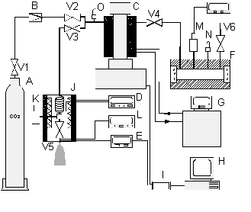

Figure X. A- CO2 cylinder; B- check valve; C- ISCO syringe pump; D,L- Omega temperature controllers; E- temperature readout; F- extraction cell; G- thermostated bath; H-computer; I- analog-digital interface; J- pre-expansion unit; K,M- Omega pressure transducers; N,O- rupture discs; V1-V6 - valves

The goal of the present work is to fabricate an abrasive microparticle blast cleaning media using the technique of rapid expansion of W/C microemulsions. We anticipate that the water core will freeze during the RESS spraying process and act as medium to produce high density ice pellet in a high velocity stream directed at the desired surface. The efficiency of the abrasive-blasted surface will be characterized by the cleanliness and roughness of the surface. Cleanliness will be evaluated based on the degree of undesirable residual contaminant present on the surface of the treated material. Visual observation of before and after pictures should provide and adequate measurement of the surface cleanliness. Roughness will be evaluated based on the micrometric shape of the surface or the surface profile. Elipsometry will be utilized to measure the surface profile of the blasted material.


Figure Y.

Expected Results or Benefits
Several of the small molecule surfactants presented in this proposal have demonstrated the capability to form reverse micelle and/or water-in CO₂ microemulsion, rendering them extremely useful in many applications. Three possible applications proposed herein include utilizing existing surfactatnts (and new surfactants as they become synthetically available) to form W/C microemulsion for formation of DNA-loaded nanoparticles, polymeric nanoparticles, and a novel abrasive cleaning media. If successful, the results from the proposed work should be useful for many of the reasons outlined below.
(1) Synthetic purity and variability - The zwitterionic gemini fluorosurfactants are readily prepared in pure form, verifiable by ¹H, ¹³C, ¹⁹F, and ³¹P NMR as well as elemental analysis and mass spectrometry (as opposed to PFPE surfactants which are commonly used in mixtures of different perfluoropolyether chain-length). Synthetic flexibility is available as chain characteristics (such as length, degree of fluorination) and spacer length/structure can be varied. This allows for systematic evaluation of surfactant structure-activity relationships in dense CO₂ to an extent far beyond what has been reported to date, and will allow for solution properties to be optimized through subtle synthetic variations.
(2) Gemini format – Surfactants possessing the gemini structural format have not yet appeared in studies involving liquid or supercritical CO₂. Thus, gemini surfactant in CO₂ systems comprise a unique coupling of two rapidly growing areas of small-molecule surfactants - geminis representing an important new direction in surfactant structure, and dense CO₂ representing an increasingly important solvent for self-assembling systems.
(3) Hybrid hydrocarbon/fluorocarbon composition – Surfactants containing both hydrocarbon and fluorocarbon hydrophobic units have been found to form microemulsions in dense CO₂.^{4,7} This “hybrid” feature may be important in two regards: (1) enhanced stabilization of discrete microemulsion droplets through lessened chain-chain interactions compared to “fully” hydrocarbon-chained or fluorocarbon-chained surfactants, and, (2) reduced cost compared to “fully” fluorinated surfactants.
(4) Low toxicity and biocompatibility - Literature reports on biocompatibility and toxicity appear to be very promising for morpholinophosphate fluorosurfactants.^{21,22} Evidence includes high mouse lethal dose (LD₅₀) levels, and low hemolytic activity (even though the surfactants are highly surface-active). Thus, CO₂-fluorosurfactant systems comprising this class could be potentially environmentally and biologically benign.

General Project Information:
The project will be managed by Professor Joseph M. DeSimone, William R. Kenan Junior Distinquished Professor of Chemistry and Chemical Engineering and Director of NSF STC Environmentally Responsible Solvents and Processes. Prof. DeSimone reports directly to the Chairman of the Chemistry Department (James Jorgenson), who reports to the Dean (Risa I Palm), who reports to the Provost (Robert Shelton) and who reports to the Chancellor. Mrs. Vicki Haithcock assists Professor DeSimone. Through previous funding, a high-pressure laboratory dedicated for extensive use with CO2 has been built and the facilities are described below:

Laboratory: The proposed effort will have access to four laboratories in the Department of Chemistry at UNC-CH. This space contains a CO₂ distribution system which is installed in all of the hoods to facilitate experiments. This laboratory space contains 8 laminar flow hoods.

MAJOR EQUIPMENT
- (a) Waters 150-CV GPC with UV-vis/DRI/viscometry detection; (b) Waters 610 with 717 Autosampler, 996 Photodiode Array Detector, 600 E System Controller, 410 Differential Refractometer, and a DAWN LALLS detector.
- Polymer Thermal Analysis Lab: Seiko EXSTAR 5300 Controller/Data station, DSC120, DSC220, RTG, TMA/SS120C, DMS210, DES 100, Cooling Accessory.
- GC-MS: HP 5890 Series II Gas Chromatograph, 5972 Series Mass Selective Detector.
- HPLC: Waters 996 photodiode Array Detector, Waters 600 pump/Controller.
- High Pressure Cells: There are various high-pressure cells in the lab, each equipped with a pressure transducer, indicator, and temperature controller.
- This work will also have access to several spectroscopic ellipsometers. An in situ ellipsometer will be modified to mate with a high pressure CO₂ chamber.

OTHER RESOURCES
NMR Lab: The NMR lab of the chemistry department is located in Venable Hall: Varian XL400, Bruker MSL360 Wide-Bore, Bruker Avance300, Bruker WM250, Bruker AC200
Other Support Services: UNC-CH has an extensive machine shop that is experienced in the design and construction of high-pressure stainless steel vessels and vacuum chambers. There is also an extensive electronics and computer support service in the university that is available for consultation on networking, data acquisition, and electronics equipment.

References
- Consider, for instance, from 1947 to 1951, the Journal of Physical Chemistry (ACS Publication) was entitled Journal of Physical and Colloid Chemistry (volumes 47-51).
- Eastoe, J.; Paul, A.; Nave, S.; Steytler, D. C.; Robinson, B. H.; Rumsey, E.; Thorpe, M.; Heenan, R. K. “Micellization of Hydrocarbon Surfactants in Supercritical Carbon Dioxide,” Journal of the American Chemical Society; 2001; 123(5); 988-989.
(3) Rindfleisch, F.; DiNoia, T. P.; McHugh, M. A. “Solubility of Polymers and Copolymers in Supercritical CO₂”, The Journal of Physical Chemistry; 100(38); 15581-15587.
(4) Israelachvili, J. N. Intermolecular and Surface Forces, 2nd ed.; Academic Press: New York, 1991.
(5) Buhler E, Dobrynin AV, DeSimone JM, Rubinstein M: “Light-scattering study of diblock copolymers in supercritical carbon dioxide: CO₂ density induced micellization transition.” Macromolecules 1998, 31, 7347-7355.
6) Fulton, J. L.; Pfund, D. M.; McClain, J. B.; Romack, T. J.; Maury, E. E.; Combes, J. R.; Samulski, E. T.; DeSimone, J. M.; Capel, M. Langmuir 1995, 11, 4241.
(7) Hoefling, T. A.; Enick, R. M.; Beckmann, E. J. J. Phys. Chem. 1991, 95, 7127.
(8) Hoefling, Beitle, R. R.; T. A.; Enick, R. M.; Beckmann, E. J. Fluid Phase Equilibria 1993, 83, 203.
(9) Harrison, K.; Goveas, J.; Johnston, K. P.; O'Rear, E. A. Langmuir 1994, 10, 3536.
(10) Johnston, K. P.; Harrison, K. L.; Clarke, M. J.; Howdle, S. M.; Heitz, M. P.; Bright, F. V.; Carlier, C.; Randolph, T. W. Science 1996, 271, 624.
(11) Eastoe, J.; Bayazit, Z.; Martel, S.; Steytler, D. C.; Hennan, R. K. Langmuir 1996, 12, 1423.
(12) Eastoe, J.; Cazelles, B. M. H.; Steytler, D. C.; Holmes, J. H.; Pitt, A. R.; Wear, T. J.; Heenan, R. K. Langmuir 1997, 13, 6980.
(13) Holmes, J. D.; Steytler, D. C.; Rees, G. D.; Robinson, B. H. Langmuir 1998, 14, 6371.
(14) Niemeyer, E. D.; Bright, F. V. J. Phys. Chem. B 1998, 102, 1474.
(15) Holmes, J. D.; Ziegler, K. J.; Audriani, M.; Lee Jr.; C. T.; Bhargava, P. A.; Steytler, D. C.; Johnston, K. P. J. Phys. Chem. B 1999, 103, 5703.
(16) da Rocha, S. R. P.; Harrison, K. L.; Johnston, K. P. Langmuir 1999, 15, 419.
(17) Jacobson, G. B.; Lee Jr., C. T.; Johnston, K. P. J. Org. Chem. 1999, 64, 1201.
(18) Jacobson, G. B.; Lee Jr., C. T.; da Rocha, S. R. P.; Johnston, K. P. J. Org. Chem. 1999, 64, 1207.
(19) Kane, M. A.; Baker, G. A.; Pandey, S.; Bright, F. V. Langmuir 2000, 16, 4901.
(20) Ji, M.; Chen, X.; Wai, C. M.; Fulton, J. L. J. Am. Chem. Soc. 1999, 121, 2631.
(21) See http://www.micell.com.
22) Heitz, M. P.; Carlier, C.; deGrazia, J.; Harrison, K. L.; Johnston, K. P.; Randolph, T. W.;
Bright, F. V. “The Water Core Within Perfluoropolyether-Based Microemulsions Formed in Supercritical Carbon Dioxide.” J. Phys. Chem. 1997, 101, 6707.
(23) Niemeyer, E. D.; Bright, F. V. “The pH within PFPE Reverse Micelles Formed in Supercritical CO₂.” J. Phys. Chem. 1998, 102, 1474.

(5) Clarke, M. J.; Harrison, K. L.; Johnston, K. P.; Howdle, S. M. “Water in Supercritical Carbon Dioxide Microemulsiosn: Spectroscopic Investigation of a New Environment for Aqueous Inorganic Chemistry.” J. Am. Chem. Soc. 1997, 119, 6399-6406.
(
(7) Zielinski, R. G.; Kline, S. R.; Kaler, E. W.; Rosov, N. “Small Angle Neutron Scattering Study of Water in Carbon Dioxide Emulsions.” Langmuir 1997, 13, 3934.
(8) Lee Jr CT, Psathas PA, Johnson KP, deGrazia J, Randolph TW: “Water-in carbon dioxide emulsions: Formation and stability.” Langmuir 1999, 15: 6781-6791.
(9) Harrison, K. L.; Goveas, J.; Johnston, K. P.; O'Rear III, E. A. “Water-in-Carbon Dioxide Microemulsions with a Fluorocarbon-Hydrocarbon Hybrid Surfactant.” Langmuir. 1994, 10, 3536-3541.
(10) Kane MA, Baker GA, Pandey S, Bright FV: “Performance of cholesterol oxidase sequestered within reverse micelles formed in supercritical carbon dioxide.” Langmuir 2000, 16:4901-4905.
(11) (a) Yazdi, A. V.; Beckman, E. J. “Design of Highly CO₂-Soluble Chelating Agents .2. Effect of Chelate Structure and Process Parameters on Extraction Efficiency” Ind. Eng. Chem. Res. 1997, 36, 2368-2374. (b) Yazdi, A. V.; Beckman, E. J. “Design, Synthesis, and Evaluation of Novel, Highly CO₂-Soluble Chelating Agents for Removal of Metals” Ind. Eng. Chem. Res. 1996, 35, 3644-3652.
(13) Eastoe, J.; Bayazit, Z.; Martel, S.; Steytler, D. C.; Heenan, R. K. “Droplet Structure in a Water-in-CO₂ Microemulsion.” Langmuir, 1996, 12 (6), 1423-1424.
(14) Eastoe, J.; Cazelles, B. M. H.; Steytler, D. C.; Holmes, J. D.; Pitt, A. R.; Wear, T. J.;
Heenan, R. K. “Water-in-CO₂ Microemulsions Studied by Small-Angle Neutron Scattering” Langmuir 1997, 13, 6980-6984.
(15) Holmes, J. D.; Steytler, D. C.; Rees, G. D.; Robinson, B. H. “Bioconversions in a Water-in-CO₂ Microemulsion.” Langmuir 1998, 14, 6371-6376.
(16) Lee, W-F; Huang, Y-L. J. Appl. Polym. Sci. 2000, 77, 1769.
(17) Choi, H.S.; Kim, J.M.; Lee, K-J; Bae, Y.C. J. Appl. Polym. Sci. 1999, 72, 1091.

(x) Mawson, S.; Johnston, K.P; Combes, J.R.; DeSimone, J.M. Macromolecules, 1995, 28, 3182-3191.
(y) Tom, J.W.; Debenedetti, P.G. Biotechnol. Prog. 1991, 7, 403.
Lele, A. K.; Sine, A. D. Polym. Prepr. (Am. Chem. Soc., Div. Polym.Chem.) 1991, 31, 677.

(x') Matson, D. W.; Fulton, J. L; Peterson, R. C.; Smith, R. D. Ind. Eng. Chem. Res. 1987, 26, 2298.

(1) Wells, S.L.; DeSimone, J. M. Angew. Chem. Int. Edit. 2001, 40, 519.

(2) (a) Harrison, K.; Goveas, J.; Johnston, K. P.; O'Rear, E. A. Langmuir 1994, 10, 3536.; (b) Johnston, K. P.; Harrison, K. L.; Clarke, M. J.; Howdle, S. M.; Heitz, M. P.; Bright, F. V.; Carlier, C.; Randolph, T. W. Science 1996, 271, 624.; (c) Eastoe, J.; Bayazit, Z.; Martel, S.; Steytler, D. C.; Hennan, R. K. Langmuir 1996, 12, 1423.; (d) Holmes, J. D.; Ziegler, K. J.; Audriani, M.; Lee Jr.; C. T.; (e) Bhargava, P. A.; Steytler, D. C.; Johnston, K. P. J. Phys. Chem. B 1999, 103, 5703.

(3) (a) Holmes, J. D.; Bhargava, P. A.; Korgel, B. A.; Johnston, K. P. Langmuir 1999, 15, 6613.; (b) Ji, M.; Chen, X.; Wai, C. M.; Fulton, J. L. J. Am. Chem. Soc. 1999, 121, 2631.

(4) Jacobson, G. B.; Lee Jr., C. T.; Johnston, K. P. J. Org. Chem. 1999, 64, 1201.

(5) (a) Holmes, J. D.; Steytler, D. C.; Rees, G. D.; Robinson, B. H. Langmuir 1998, 14, 6371.; (b) Kane, M. A.; Baker, G. A.; Pandey, S.; Bright, F. V. Langmuir 2000, 16, 4901.

(6) Sadtler, V. M.; Jenneaux, F.; Krafft, M. P.; Rabai, J.; Riess, J. G. New. J. Chem. 1998, 22, 609.

(7) Peresypkin, A. V.; Menger, F. M. Org. Lett. 1999, 1, 1347.

(8) O'Neill, M. L.; Cao, Q.; Fang, M.; Johnston, K. P.; Wilkinson, S. P.; Smith, C. D.; Kerchner, J. L.; Jureller, S. H. Ind. Eng. Chem. Res. 1998, 37, 3067.

(9) Dardin, A.; DeSimone, J. M.; Samulski, E. T. J. Phys. Chem. B. 1998, 102, 1775.

(10) Sarbu, T.; Styranec, T.; Beckman, E. J. Nature 2000, 405, 165.

(11) Eastoe, J.; Paul, A.; Nave, S.; Steytler, D. C.; Robinson, B. H.; Rumsey, E.; Thorpe, M.; Heenan, R. K. J. Am. Chem. Soc. 2001, 123, 988.

(12) Birault, V.; Pozzi, G.; Plobeck, N.; Eifler, S.; Schmutz, M.; Palanche, T.; Raya, J.; Brisson, A.; Nakatani, Y.; Ourisson, G. Chem. Eur. J. 1996, 2, 789.

(13) Lee Jr., C. T.; Bhargava, P.; Johnston, K. P. J. Phys. Chem. B 2000, 104, 4448.
Resume
JOSEPH M. DESIMONE
William R. Kenan, Jr. Distinguished Professor of Chemistry and Chemical Engineering
Department of Chemistry Office: (919) 962-2166
CB #3290 Venable & Kenan Laboratories Fax: (919) 962-5467
University of North Carolina at Chapel Hill desimone@unc.edu
Chapel Hill, NC 27599-3290 and
Department of Chemical Engineering
North Carolina State University
Raleigh, NC 27695

Professional Preparation:
B.S. Chemistry, Ursinus College; May, 1986.
Ph.D. Chemistry, Virginia Polytechnic Institute and State University; March, 1990.

PROFESSIONAL POSITIONS
1999 - Director, NSF Science and Technology Center for
Environmentally Responsible Solvents and Processes
1999 - William R. Kenan Jr. Distinguished Professor of Chemistry at UNC-CH and
Chemical Engineering at NCSU
1997 - 1999 Co-Director, Kenan Center for the Utilization of CO₂ in Manufacturing
1996 - 1999 Mary Ann Smith Professor of Chemistry (at UNC-CH) and
Professor of Chemical Engineering (at North Carolina State University)
1995 Mary Ann Smith Associate Professor of Chemistry (at UNC-CH) and Chemical Engineering (at North Carolina State University)
1990 - 1994 Assistant Professor of Chemistry, UNC-CH

HONORS, AFFILIATIONS AND SERVICE
- 2000 Oliver Max Gardner Award by the Board of Governors at UNC-CH
- 1999 Fresenius Award of PHI LAMBDA UPSILON Honorary Chemical Society
- Carl S. Marvel Creative Polymer Chemistry Award (1999)
- Honorary Doctorate of Science from Ursinus College (1999)
- Alfred P. Sloan Research Fellowship (1998-2001)
- R&D 100 Award with Micell Technologies (1998)
- Presidential Green Chemistry Challenge Award (1997).
- Governor’s Award for Excellence (1997)
- Chancellor’s Award for Excellence (1997)
- Co-founder and Chairman, MICELL Technologies, Inc., (1996-)
- 1995 Charles H. Stone Award.
- Presidential Faculty Fellow Award (1993-1997).
- National Science Foundation Young Investigator - Div. Materials Research (1992).

SELECTED PUBLICATIONS
1. “Design of Nonionic Surfactants for Carbon Dioxide”; McClain, J.B.; Betts, D.E.; Canelas, D.A.; Samulski, E.T.; DeSimone, J.M.; Londono, J.D.; Cochran, H.D.; Wignall, G.D.; Chillura-Martino, D.; Triolo, R. Science 1996, 274, 2049.
2. “Dispersion Polymerizations of Styrene in Supercritical Carbon Dioxide: Importance of Effective Surfactants”; Canelas, D.A.; Betts, D.E.; DeSimone, J.M. Macromolecules 1996, 29, 2818.
3. “Solution Properties of a CO₂-Soluble Fluoropolymer in Supercritical Carbon Dioxide”;
McClain, J.B.; Londono, J.D.; Combes, J.R.; Romack, T.J.; Canelas, D.A.; Betts, D.E.; Wignall, G.D.; Samulski, E.T.; DeSimone, J.M. J. Am. Chem. Soc. 1996, 118, 917.
4. "Synthesis of Fluoropolymers in Supercritical Carbon Dioxide"; DeSimone*, J. M.; Guan, Z.; Elsbernd, C. S. Science 1992, 257, 945-947.
5. "Dispersion Polymerizations in Supercritical Carbon Dioxide"; DeSimone*, J. M.; Maury, E. E.; Menceloglu, Y. Z.; Combes, J. R.; McClain, J. B.; Romack, T. Science 1994, 265, 356.
6. “Liquid-Liquid Extractions Using Dendrimer-Modified Carbon Dioxide”; Cooper, A. I.; Londono, D.; Wignall, G.; McClain, J. B.; Samulski, E. T.; Lin, J. S.; Dobrynin, A.; Rubinstein, M.; Burke, A. L. C.; Frechet, J. M. J.; DeSimone, J. M. Nature 1997, 389, 368-371.
7. “Dispersion Polymerizations in Carbon Dioxide Using Siloxane-based Stabilizers”; Shaffer, K. A.; Jones, T. A.; Canelas, D. A.; DeSimone, J. M. Macromolecules 1996, 29, 2704-2706.
8. “Aggregation of Amphiphilic Molecules in Supercritical Carbon Dioxide: A Small Angle X-ray Scattering Study”; Fulton, J. L.; Pfund, D. M.; McClain, J. B.; Romack, T. J.; Maury, E. E.; Combes, J. R.; Batten, H.; Samulski, E. T.; DeSimone, J. M. Langmuir 1995, 11, 4241-4249.

Collaborators
Mirielle Adam, visiting scientist at Department of Chemistry, UNC-CH
Ben Chu, Department of Chemistry, Stony Brook State University of NY
Mark McHugh, Department Chemical Engineering, Johns Hopkins University
Paul Resnick, DuPont Corporation
Robert Gilbert, Department of Chemistry, University of Sydney, Sydney, Australia
Alex van Herk, Eindhoven Technical University, Eindhoven, The Netherlands
Keith Johnston, Department of Chemical Engineering, University of Texas at Austin
Ruben Carbonell, George Roberts, Bob Kelly, Rich Spontak, Benny Freeman, Department of Chemical Engineering, NC State University
Maurice Brookhart, Ed Samulski, Richard Linton, Tom Meyer, Malcolm Forbes, Charles Johnson, Department of Chemistry, UNC-CH

Graduate and Postdoctoral Students Advised
Postdoctoral Research Associates (past and present – 20 total)
Dr. Richard Lemert, Dr. Yusuf Menceloglu, Dr. Scott Archibald, Dr. James Combes, Dr. Jun Lin, Dr. Katherine Schaffer, Dr. Kerstin Kapellen, Dr. Yu-Ling Hsiao, Dr. Andrew Cooper, Dr. Geni Dessipri, Dr. Alex Dardin, Dr. Kim Powell, Dr. Shobha Kantamneni, Dr. Murat Quadir, Dr. Yizeng Ni, Dr. Gina Stewart, Dr. James DeYoung, Dr. Jonathan Kendall, Dr. Eric Buhler, Dr. Han-Chao Wei, Dr. Darlene K. Taylor

Graduate Students (past and present – 27 total)
Dr. Mark Peters, Dr. Elise Maury, Dr. Zhibin Guan, Dr. Michael Hunt, Jr., Dr. Valerie Sheares, Dr. Shonali Tahiliani, Dr. Michael Clark, Dr. Katrina Dukes, Dr. Chad Mistele, Dr. Tim Romack, Dr. Martha Tanner, Dr. Dorian Canelas, Dr. Brian Kipp, Jim McClain, Richard Phillips, Doug Betts, Kim Maxwell, Amy Burke, Ramone Givens, Clay Bunyard, Terri Johnson, Jennifer Young, Sharon Wells, Tamara Jones, Steven Gross, Scott Shultz, Devin Flowers

ITEMIZED BUDGET FOR STAR-01 GRANT APPLICATION

CATEGORIES |  | Year 1 |  | Year 2 |  | Year 3 |  | Total
a. Personnel
Principal Investigator |  | 13,173 |  | 13,832 |  | 14,524 |  | 41,529
Postdoctoral (1) |  | 33,000 |  | 34,650 |  | 36,383 |  | 104,033
Graduate students (1) |  | 18,000 |  | 18,000 |  | 18,000 |  | 54,000
20% Secretarial |  | 7,200 |  | 7,488 |  | 7,787 |  | 22,475
Total Personnel Costs |  | 71,373 |  | 73,970 |  | 76,694 |  | 222,037
b. Fringe benefits |  | 8,718 |  | 9,026 |  | 9,347 |  | 27,091
c. Travel
Trip 1 (student ) |  | 2,000 |  | 2,000 |  | 2,000 |  | 6,000
Trip 1 (Postdoc) |  | 2,000 |  | 2,000 |  | 2,000 |  | 6,000
Trip 1 (PI) |  | 2,000 |  | 2,000 |  | 2,000 |  | 6,000
Total Travel Costs |  | 6,000 |  | 6,000 |  | 6,000 |  | 18,000
d. Tuition |  | 1,966 |  | 1,966 |  | 984 |  | 4,916
e. Publications |  | 1,000 |  | 1,000 |  | 1,000 |  | 3,000
f. Supplies
Item 1 (Student 1) |  | 7,500 |  | 6,050 |  | 5,025 |  | 18,575
Item 2 (Postdoc) |  | 7,500 |  | 6,050 |  | 5,025 |  | 18,575
Total Supplies Costs |  | 15,000 |  | 12,100 |  | 10,050 |  | 37,150
Total direct costs |  | 104,057 |  | 104,062 |  | 104,075 |  | 312,194
Indirect costs  45.5% of direct cost |  | 46,451 |  | 46,454 |  | 46,906 |  | 139,811
Total Project Costs |  | 150,508 |  | 150,516 |  | 150,981 |  | 452,005
TOTAL REQUESTED FROM EPA |  | 150,508 |  | 150,516 |  | 150,981 |  | 452,005

Budget Justification

• Faculty salary are based on one month per grant year of academic year or summer salary, with a 5% increase allowed from year to year.

• One postdoctoral and one graduate student will be assigned to the PI per year.

• 20% of secretarial time (0.2 x $36,000 base pay for first year) and (0.2 x 4% increase on base for subsequent years).

• Fringe benefits at UNC Chapel Hill are calculated as follows: 19% of faculty salaries; 7.65% of postdoctoral salaries plus $1,416 per year for health insurance; $908.04 per year per graduate student.

• Travel funds are allowed to attend scientific and technical meetings.

• Materials and supplies costs are estimated at $7,500 per graduate and postdoctoral student. These include general laboratory supplies.

• Publication costs includes copying of manuscripts, purchase of reprints, costs of producing posters and other presentations as well as reports to the sponsors.

- Indirect cost rates at UNC Chapel Hill will be 45.5% after July 1, 2001. Indirect costs are based on all direct costs except tuition.

QUALITY ASSURANCE NARRATIVE STATEMENT

This proposal does not involve the collection of environmental data, and therefore, items 1-7 and 9-10 of the Quality Assurance Narrative Statement are not included here. Instead, we propose alternative synthetic routes to nanoparticles that when employed, can be used to realize a great reduction of pollution production caused during the manufacture of drug delivery systems and other applications. Efficient removal of the surfactants from the nanoparticles products by supercritical carbon dioxide extraction will also be a requirement. The surfactants will be characterized by NMR, IR, GPC, scattering techniques and thermal analysis and compared to the corresponding physical data of polymers synthesized in traditional solvent systems. If yields and physical data of surfactants are equal (or superior) to the commercial samples, we will have presented at viable, more environmentally friendly alternative to traditional organic solvents for the synthesis of these nanoparticles.

