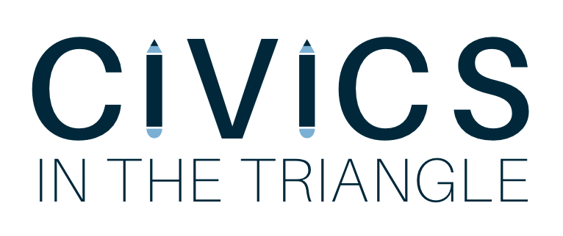
LESSON 8: Field Trip Reflection
North Carolina Legislative Building and North Carolina Museum of History
April 13th, 2018

What was your favorite part about the field trip?

What was one thing you learned about North Carolina government?

Think back to our last Civics lesson about a mock election… how did your campaign advertisement relate to this field trip?

What does it mean to be a responsible citizen?

