SOUTHERN IMPRESSIONS
Paintings from the James-Farmer Collection

NOTES: * southern born artist
! North Carolina native artist

THE LANDSCAPES
NCMOH associated artifacts:
(locate somewhere in the Landcsape section)
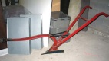 2005.74.1 Case 1
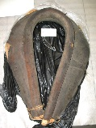 2009.49.1, Mule collar
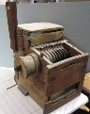 2012.41.1, cotton gin
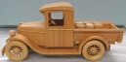 2015.9.1

NCMOH associated artifacts:
(locate somewhere at the end LANDSCAPE section and beginning of PEOPLE section))
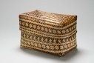 1990.195.1, Case 2
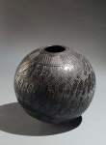 2008.69.1 Joel Queen pot
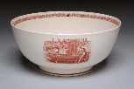 2006.23.200
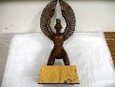 1985.193.1 Eagle Dancer
OR
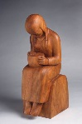1996.68.1

#1
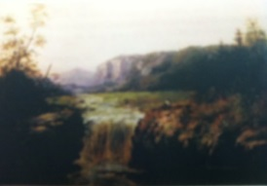
William Charles Anthony Frerichs (1829-1905)
Netherlands
Falls of the Tamahaka, Cherokee County, North Carolina

William Charles Frerichs was lured to teach at Greensboro College, Greensboro, North Carolina. He was later conscripted by the Confederate Army as a civil engineer in the Sauratown Mountains. Frerichs is believed to have been the first artist to visually define the waterfalls, gorges, and fauna around the French Broad River and Sauratown Range.

#2
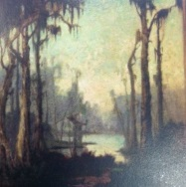
Knute Heldner (1875/77-1952)
Sweden
Swamp Scene with Cabin

Knute Heldner has the distinction of being the only artist to capture the both the headwaters and the terminuses of the Mississippi River. He participated in the Works Progress Administration Federal Art Project for Lousiana and gained national and international recognition for his landscapes in that state.

#3
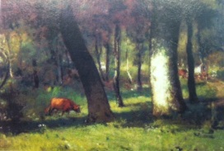
Elliot Dangerfield (1859-1932) *
Virginia/North Carolina
Carolina Woodland

Elliot Dangerfield is one of the most famous artists with North Carolina roots. He believed in a strong link between nature and spirituality. The state’s landscape, partly pastoral, partly wild, and partly isolated, served as a focus for his idealized moody landscape style.

#4
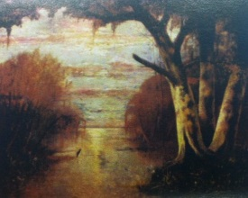
Joseph Rusling Meeker (1827-1889)
New Jersey
Yazoo Pass, Mississippi

Joseph Rusling Meeker served as paymaster for a United States Navy gunboat deployed in the Louisiana swamps during the Civil War. This rich experience gave him the inspiration for his signature subject, the sultry and the mythic Louisiana swamp country.

#5
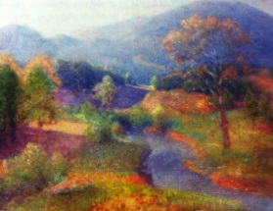
Lawrence Mazzanovich (1872-1959)
California
North Carolina Mountains

Lawrence Mazzanovich moved to the small unique artist community of Tryon, North Carolina in the early 1920’s. Mazzanovich, who had a love and reverence for nature, stated that he had “found his place” in the Blue Ridge Mountains.

#6
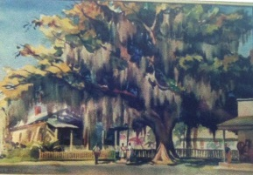
William Lester Stevens (1888-1969)
Massachusetts
Savannah Scene

William Lester Stevens, who painted outside every day, was liked by Southerners for his views of Southern cities and gardens. He had a goal of making art more accessible to common people. Stevens concluded that “fine pictures are the result of fine minds.”

#7
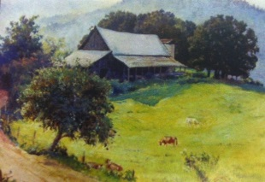
Hattie Saussy (1890-1978) *
Georgia
Farm in Appalachian Mountains

Hattie Saussy blind in one eye, focused her art on Southern landscapes and culture. She co-founded the Association of Georgia Artists in 1929. Saussy was adept at capturing a particular feeling at a specifc moment and place.

#8
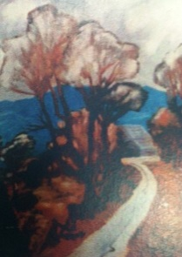
Anne Wilson Goldthwaite (1869-1944) *
Alabama
Fauvist Landscape Keep

Anne Wilson Goldthwaite and family part of the former aristocratic South, became an etcher, painter, and staunch supporter of women’s causes. Goldthwaite spoke on radio in 1924 about women artists stating “We want more . . . without prejudice . . . an audience that asks simply is it good, not—was it done by a woman.”

#9
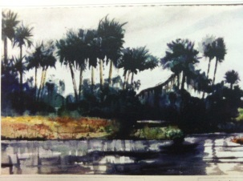
Alice Ravenel Huger Smith (1876-1958) *
South Carolina
Isle of Palms

Alice Ravenel Huger Smith contributed to the revival of the awareness of Southern culture and heritage through her literary efforts and art. She was at the center of the Charleston’s artisitic Renaissance during the 20th century along with Hutty, Verner, and Taylor. Smith was a founding member of the Southern States Arts League.

#10
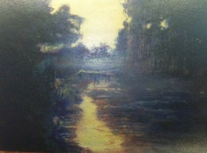
Walter Whitcomb Thompson (1852-1948) *
South Carolina
Sunrise on the Edisto

Walter Whitcomb Thompson devout local landscape painter and teacher inspired his students with his love of nature. He founded the Combahee River Art Colony and the Beaufort-Brevard Art Colonies. Thompson stated “There is beauty in Nature, rich, vibrant, soul-stirring color . . . and [we] drink thirstily until we gladly become drunken through our eyes.”

#11
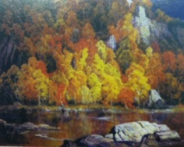
Rudolph F. Ingerie (1879-1950)
Austria
French Broad River, Western North Carolina

Rudolph F. Ingerie visited and fell in love with the Great Smokey Mountains and its people around 1920, calling them “the grandest people in the world. . . .” Due to Ingerie’s and other’s efforts in 1934, the Great Smokey Mountains National Park was officially established to protect the threatened natural beauty of the area.

#12
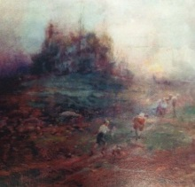
Enoch Lloyd Branson (1853-1925) *
Tennessee
Barbizon Landscape

Enoch Lloyd Branson’s European trip in 1875-1876 exposed him to new international and national art trends. His experience enabled him to surpass many of his Southern contemporaries knowledge of developing art world trends.

THE PEOPLE

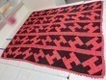 2015.5.1 domestic servant Case 3
2004.152.1
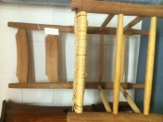 1993.56.1
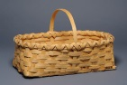 2004.135.1 Neil Thomas
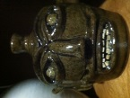 2008.69.1

NCMOH associated artifact:
(located close to Civil War images of Lee and Jackson)
R#5583.21 Gen. Orders #9, Beallmont Case 4
R#5493.1 S. Richardson gun
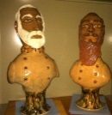 20015.1-2, Jackson and Lee
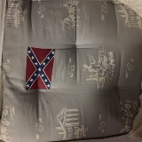2001.51.1 Dixie mattress

NCMOH associated artifact:
(located at end of people and beginning of CULTURE) Case 5
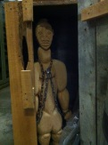 1996.117.1 slave in a box

#13
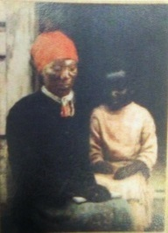
Augustus Goodyear Heaton (1844-1930)
Pennsylvania
Grandmother and Child

Augustus Goodyear Heaton numismatist, painter of portraits and historical subjects, most famous work is The Recall of Columbus, purchased by the United States Senate. Like many American painters, Heaton also chose a moral lesson in his paintings over stirring actions.

#14
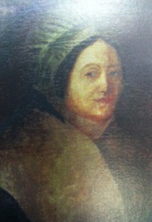
Sarah Miriam Peale (1800-1885)
Pennsylvania
Planter’s Wife

Sarah Miriam Peale of the infamous Peale family of painters was considered the leading portrait painter of Baltimore and St Louis during the mid-19th century. Peale received more portrait commissions than her leading male contemporaries Thomas Sully and John Vanderlyn.

#15
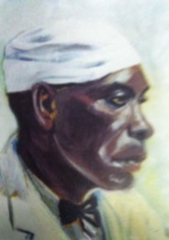
Edwin Augustus Harleston (1882-1931) *
South Carolina
The Cook

Edwin Augustus Harleston, born to a prosperous African American family in Charleston, South Carolina, studied under W.E.B. DuBois at Atlanta University and later enrolled at the prestigious School of the Museum of Fine Arts in Boston. He opened a studio with his wife Elise, a well-respected photographer. DuBois described him as “the leading portrait painter of the race.” Harleston was also a co-founder of the NAACP.

#16
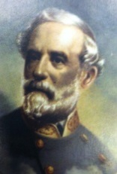
William H.M. Cox (birthdate unknown-1909)
Missouri
Robert E. Lee

William H. M. Cox portrait and landscape painter worked in Richmond, Virginia after the Civil War 1865-1867. It is said Lee refused Cox’s invitation to sit for his portrait. Cox’s unique positioning of Lee is not found on any other known portrait of Lee.

#17
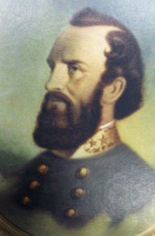
William H.M. Cox (birthdate unknown-1909)
Missouri
Stonewall Jackson

William H. M. Cox portrait and landscape painter worked in Richmond, Virginia after the Civil War 1865-1867. Cox’s portrayal of Jackson and Lee “in the clouds” is unusual.

#18
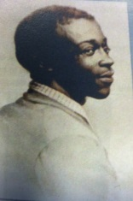
Maria Howard Weedon (1847-1905) *
Alabama
John Rucker “Bandana Ballad”

Maria Howard Weedon, daughter of a physician and cotton planter, is best known for her watercolors of former slaves and poetry based on slave stories often written in a regional black dialect. Weedon believed her contemporary artist’s portraits of former slaves lacked individuality and character. Her goal was to record them with love and respect.

#19
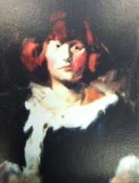
Hilda Lanier Ogburn (1895-1984) *!
Guilford County, North Carolina
Red Headed Woman

Hilda Lanier Ogburn is known for her “scrap sketches”, fine art, and commercial work in Greensboro, North Carolina. Ogburn was hired as the first fulltime director for the Greenville, North Carolina Museum of Art established as part of the Federal Art Project in 1939.

#20
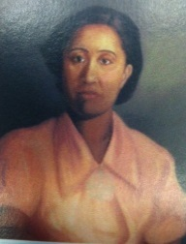
William Arthur Cooper (1895-1974) *!
Hillsborough, North Carolina
The Natural Musician

William Arthur Cooper, African American, self-taught artist, received his bachelor’s degree from the National Religious Training School in Durham (now North Carolina Central University.) Cooper’s book of 1936 A Portrait of Negro Life purpose was to “showing the real Negro through art. . . . My hope is that this little book may make its silent contributions to Race appreciation, Race development, Race adjustment and interracial good will . . .”
#21
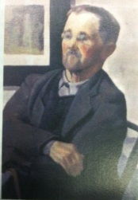
James Augustus McLean (1904-1989) *!
Lincolnton, North Carolina
Old Man in Chair

James Augustus McLean artist and teacher, founded the Southern School of Creative Arts in Raleigh, North Carolina in 1929, became one of the founding members of the North Carolina Association of Professional Artists, and established the Raleigh Little Theatre in the 1930’s.

#22
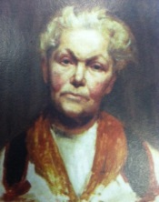
Ella Sophonisba Hergesheimer (1873-1945)
Pennsylvania
Portrait of a Lady or My Aunt ???

Ella Soponisba Hergesheimer, like her Great Great Grandfather Charles Wilson Peale became a successful painter. Ella was known for her numerous Tennessee subjects and printmaking. She exhibited her work extensively throughout the south and won several gold medals.
NCMOH associated artifact:

#23
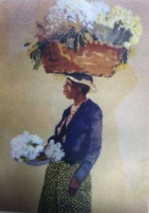
Alfred Heber Hutty (1878-1954)
Michigan
Lady with Flower Basket

Albert Heber Hutty first visited Charleston in 1919 writing his wife stating “Come quickly, have found heaven.” He became a central figure in the Charleston South Carolina Renaissance.

#24
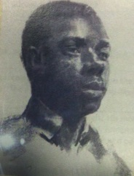
Francis Wayland Speight (1896-1989) *!
Bertie County, North Carolina
Black Male

Francis Wayland Speight, artist and prolific teacher, was born at Sharrock plantation in Bertie County. Speight credited his first teacher, Ida Poteat, art instructor at Meredith College, “in seeing art as an essential part of living a good life.” He married artist Sarah Blakeslee. In 1961, Speight became the artist in residence for East Carolina University.

#25
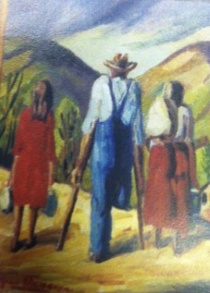
Eugene Healan Thomason (1895-1972) *
South Carolina
Going Home

Eugene Healan Thomason is recognized as the “Ashcan Artist of Appalachia.” Ashcan Artists perceived their art as portraying the gritty earthy familiar realism of the “American experience.” Thomason’s series of paintings that record the fictional Appalachian Hankin’s family forgo the typical mountaineer stereotype.

THE CULTURE

NCMOH associated artifact:
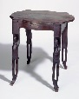 1998.145.1 Case 6
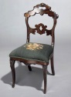 1983.4.1 TD Poteat chair

NCMOH associated artifact:
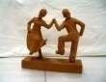 1972.63.18
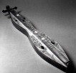 1981.235.1 Case 7
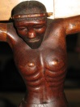 2013.10.1, Servance crucifix
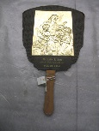 2013.23.55
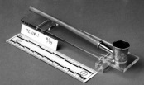 1972.118.1 coin silver woman’s pipe
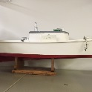 1993.28.1 shad boat model

#26
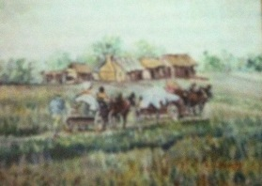
Guy Phelps (20th Century)
American
On the Road Down South

Guy Phelps was active in Florida during the 1940’s – 1970’s. Very little is known about this artist. Phelps’ modified impressionistic technique of this genre painting is compelling.

#27
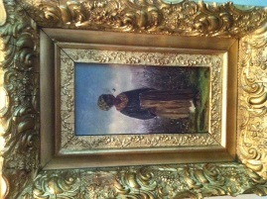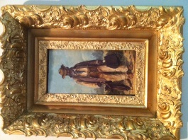
William Aiken Walker (1838-1921) *
South Carolina
Black Female and Black Male

William Aiken Walker served as a draftsman for the Confederate Corps of engineers. He is known for his prolific genre images of the plantation, African Americans and their way of life. Walker was likely the first Southern artist to make a living from the tourist trade.

#28
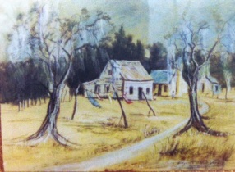
Attributed to Elizabeth Quale O’Neill Verner (1883-1979) *
South Carolina
Tenements Outside Charleston

Elizabeth Quale O’Neill Verner is recognized as the best 20th century woman artist of South Carolina and considered the matriarch of the Charleston Renaissance. Verner captured the unique spirit of Charleston’s peoples and architecture.

#29
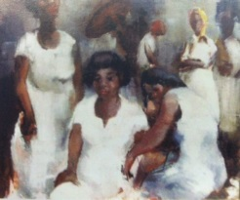
Eugene B. White (1913-1966)
Ohio
The Baptism

Eugene B. White, teacher and impressionist painter, documented the local culture and landscapes of Georgia, Florida, and North Carolina. White once said “ The true artist sees beauty in the golden sunshine on streets and houses, on the bright and faded clothing of men, women, and children—everywhere there is beauty.”

#30
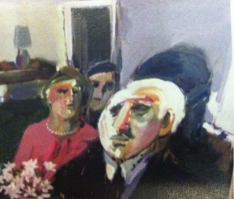
Maude Florence Gatewood (1934-2004) *!
Yanceyville, North Carolina
A Death in the Family

Maude Florence Gatewood is regarded as one of the most important 20th century artists of North Carolina. Her achievements are lauded in the documentary film Gatewood: Facing the white canvas. Gatewood, highly individualistic and independent, insisted “her paintings were her statement.”

#31
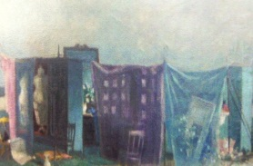
Hobson Lafayette Pittman (1899/1900-1972) *!
Epworth (Tarboro vicinity), North Carolina
Nostalgic Scene

Hobson Lafayette Pittman artist and teacher, was well known for his haunting nostalgic interiors often containing ethereal figures, definitive still-lifes, and dream-like landscapes. His flowery southern accent was compared to the oratory style used by Southern Baptist preachers. Pittman stated “I firmly believe in the keenest observations of Nature and a constant study of and reflection on . . . at large.”

#32
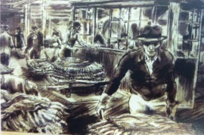
Aaron Bohrod (1907-1992)
Illinois
Tobacco Auction

Aaron Bohrod, American scene painter and illustrator, sought out “backyards and alleys, garage eaves and rooftops, parks, and the setting for the life of everyday people.” Bohrod served as a World War II artist in Europe for the United States Department of Engineers and Life magazine to record war events.

#33
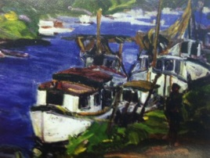
Claude Flynn Howell (1915-1997) *!
Wilmington, North Carolina
Docks at Southport, North Carolina

Claude Flynn Howell painter, teacher, and master of color, was characterized as the “Dean of North Carolina Painters.” He painted the peoples, culture, and landscape of his coastal fishing community throughout his life. Howell refused to “paint anything unless I know all about it.”

#34
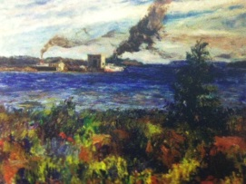
Albert Kenneth Ness (1903-2001)
Michigan
Coastal Scene near Southport, North Carolina

Albert Kenneth Ness first came to North Carolina as the Carnegie Resident artist at the University of Chapel Hill in 1941-1943. He later served as a professor and acting head of the art department at UNC. Ness founded the University of North Carolina Arts Council and was instrumental in in the development of the Ackland Art Museum.

#35
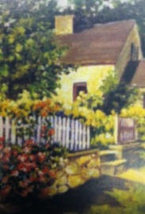
Sarah Mabel Pugh (1891-1986) * !
Morrisville, North Carolina
Flower Garden Behind Cottage

Mabel Pugh, graduate and teacher Peace College, led an active career as an illustrator for McCall’s, Ladies’ Home Journal, and The Forum. She authored and illustrated a small children’s volume, Little Carolina Bluebonnett in 1933. Pugh is one of North Carolina’s celebrated female artists.

#36
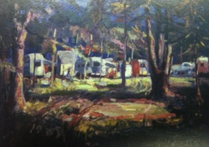
James Pearce Wharton (1893-1963) *
South Carolina
Trailer Park, Hendersonville, North Carolina

James Pearce Wharton illustrator and artist, was a member of the Southern States Artists League. Wharton served as head of several university art departments.

#37
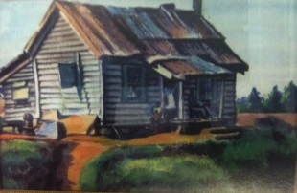
Emil Eugen Holzhauer (1887-1986)
Germany
Shack

Emil Eugen Holzhauer artist and teacher, is associated with the American Scene movement. He often painted simple scenes of daily life and the homes and neighborhoods of the working class in a non-Judgmental style.

