Praying Outside
by Abdul Rahman Latif
Praise belongs to Allah, we praise him, and we ask him for guidance and forgiveness. And we seek protection in Allah from the malice of our own souls, and the evil of our actions. Whom Allah guides, no one can lead him astray, and whom He makes astray, no one can lead him back to the right path. I bear witness that there is no other deity but Allah, by himself, no associate to him, and I bear witness that Muhammad is his slave and Messenger.
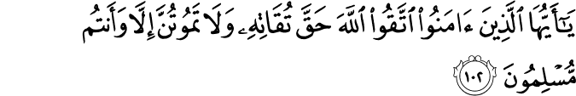
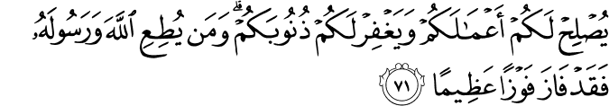
"O you who believed! Fear Allah as He should be feared, and die not except as Muslims." [Suratu Aali 'Imran 3:102] [70] "O you who believed! Fear Allah, and (always) say a word directed to the truth. [71] "That He may make your conduct whole and sound, and forgive you your sins: he that obeys Allah and His Messenger, has then attained the highest Achievement." [Suratu AlAhzaab – 33: 70 71]

Asalamualikum Y’all,
It’s an honor to be here with yall today. We stand here- well I stand, you sit here- in the open air, on UNC’s green grass, under God’s blue sky joined together in worship and praise of the divine. It was a UNC student, Myra Noor, who came up with the idea of praying out here, in communion with nature and in the eye of public, and it was UNC students who made this a reality. Mashallah.
As it so happens, precedence was set for actions today, centuries ago. Persecution after the first few years of revelation was so intense that Muslims fled/migrated to Abyssinia, modern day Ethopia, for refuge. Abu Bakr, one of the first converts, was going to join them, but his friend ibn at-Tagunna stopped him. Ibn at-Tagunna offered him protection- in other words, if anyone messed with Abu Bakr, they would be answerable to Ibn at-Tagunna and his tribe. Ibn At-Tagunna asked Abu Bakr to pray inside- to hide his acts of faith- in order to guarantee his safety. Abu Bakr did so for a while, but in the end he could not resist the urge to worship in the open air. He went to the garden in front of his house and prostrated himself in prayer
The Quraysh- the denizens of the city- rushed to Ibn At-Tagunna and confronted him. He was forced to bring Abu Bakr and ultimatum: either pray inside where no one could see, or Ibn At-Tagunna would have to revoke his protection. Abu Bakr thanked him for trying and said that the protection of God would be enough for him. He went to the Kabaa, formerly a place of worship to the One God, now a place of pagan worship- and lowered his hands in prayer. The Quraysh attacked before he finished, beat him bloody. Still he came again and again, bowing and prostrating before the divine despite the blows. Insisting on the right to pray in public. To the feel the wind on his face and the sun on his back as his heart soared.
We live in country where we have freedom of religion. We are on a public university campus where can reserve a quad and set down mats if we choose. We have freedom of speech- the ability to say who we are, articulate our beliefs, discuss them, and create brighter tomorrows. Theoretically.
It doesn’t always feel this way. When we take expressions of our religion beyond closed doors, we are threatened and no one seems to be able to guarantee our protection. The adhan will be called from on high at a neighboring university, but anonymous calls swear that it will be otherwise or else. Our brother and two of our sisters who bring their faith with them wherever they go… are killed. Because of “parking disputes.” Every other comment sections curses us, proclaims that we are monsters- inhuman, unworthy of breath. Secular logic commands us to our faith privatized, to reduce the use of “God” in our vocabularies. It frowns when someone wears a scarf, it butchers the pronunciation of some our names.
We become scared- and rightly so. Mohammed becomes Mo, Harris is Harry- if he’s British at least. We start to assimilate in dress, in speech, and action. Otherwise employment becomes risky. Otherwise the stares become too much. We swear to God that “we are just like you.” We pray behind closed doors.

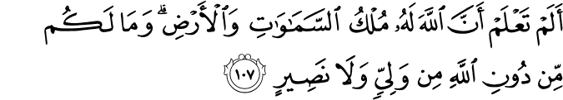
“Do you not know that to Allah belongs the dominion of the heavens and the earth and [that] you have not besides Allah any protector or any helper?”
If the heavens and the Earth is God’s, why should any of his creation have to hide?
To be clear, if prefer to keep our faith private, if we enjoy keeping it internal, that’s not a problem. But if we wish to externalize it, to live it in visible dimensions of ourselves, we should be able to. Without fear. Our difference should not ostracize us.
We trust in God and we pray to him. But what can we do to change this?
The Prophet once said, if you see an injustice, change it with your hand. If you cannot do that, speak out against it. And if you cannot do that, attest against it in your heart.
The first answer of Abu Bakr. To go outside anyways, and live it. To do what we are doing right now. It forces the issue, it makes society choose between between oppression and openness. And when we are confident in what we do people begin to respect it.
A friend of mine used to pray in the hallway in his high school. He would occasionally get comments and stares and want to melt away. He didn’t explain what he was doing to everyone, so half the people thought the guy was mad doing yoga by the wall. But right before graduation a girl came up to him. A very conservative Christian who had been raised in an “I-hate-Islams” environment. And she said, “I noticed you’ve been praying. And I really respect that.” She could see it, relate to it, and understand the persistence.
This is not always a reasonable answer. Sometimes it’s really not safe to showcase our Islam. And we may not want to. To be honest, my friend and I both have serious male privilege in being able to pray out and about and not fear assault.
In today’s world, speech has become “change by hand.” No one should be obligated to represent 1.6 billion muslims- and no one should feel that they do accurately represent 1.6 billion muslims- but as the prophet said more or less, the best jihad is to speak truth to tyranny. Let’seducate ourselves on why we should not be ashamed to be muslims. That doesn’t mean we claim “Islam is perfect”, or that we have no problems, because Allah knows we do, but we gotta be able to speak with pride on who we are. Let’s be aware of oppression so that we can lend our voices in support of the oprressed. We need to understand the tricks of islamophobia, so that we can speak up. Everyone needs to look up the bridges initiative at Georgetown which shows that Islamophobia exists, which documents what actually is happening and how- this is UNC, so yes you have homework from a khutbah, look it up. Haters gonna hate, but they also gonna choke on data.
To the non-Muslims here- I ask that you do the same. Your very presence here is an act of solidarity and makes us welcome. It speaks volumes to who you are- to be open to people who are literally labeled as strange. Please keep this up, and bring others. I know I sound angry, but we can’t smile oppression away. Accept it when we complain because their usually reason for it, and show support.
Part 2
“A tyrant and the one who helps an oppressor as well as the one who is pleased with such injustice-all the three are accomplices in the sin”–Imam Muhammad al-Baqir (RAA)
Even as feel oppression we must not support oppression. As Dr. King said, Injustice anywhere is a threat to justice everywhere.
The same system that makes people uncomfortable when a hijabi boards a plane spends a lot more time worrying when a black man wears a hood. It is the system that shot and killed Trayvon and Freddie Gray for walking outside. It is the system that killed Tanesha Anderson and Gabriella Nevarez. One should be able to be black in public. The fact that we still need to say that decades after the civil rights movement is a national disgrace.
There were actually Muslim groups who condemned the Baltimore protests. They forget that there are black Muslims. They forget that we are against all injustice- the prophet never specified about who the victim need be. They forget that we are riding the coattails of the civil rights movement. We cannot forget.
If we wish to be able to muslims publicly, we should all be able to express ourselves within and without our communities. It can’t just be men. I am a male speaking here right now- whatever you believe, question that. Where are the voices of sisters? Are they not allowed in public? In many so-called muslim societies they are not. This is the same fight.
If we are using the metaphor of indoors and outdoors, we cannot neglect mentioning the LGBTQ community. There are gay, lesbian, trans, bi, and queer muslims who “stay in the closet.” I understand Muslims are divided on this, but we cannot push people away from our community. Let that at least be the common ground. And as Hamza said last week, when a black trans-woman is killed, it had better be our problem too.
When Abu Bakr (RA) prayed outside like we are doing here, he wasn’t building a victory mosque or gloating- for the love of Allah he was brutalized. No, he was exerting his right to be there. He was saying that we should not be ignored. We are and we will be.
As the Prophet (SAW) said, “Islam initiated as something strange, and it will revert to its (old position) of being strange. So, glad tidings to the stranger!”

