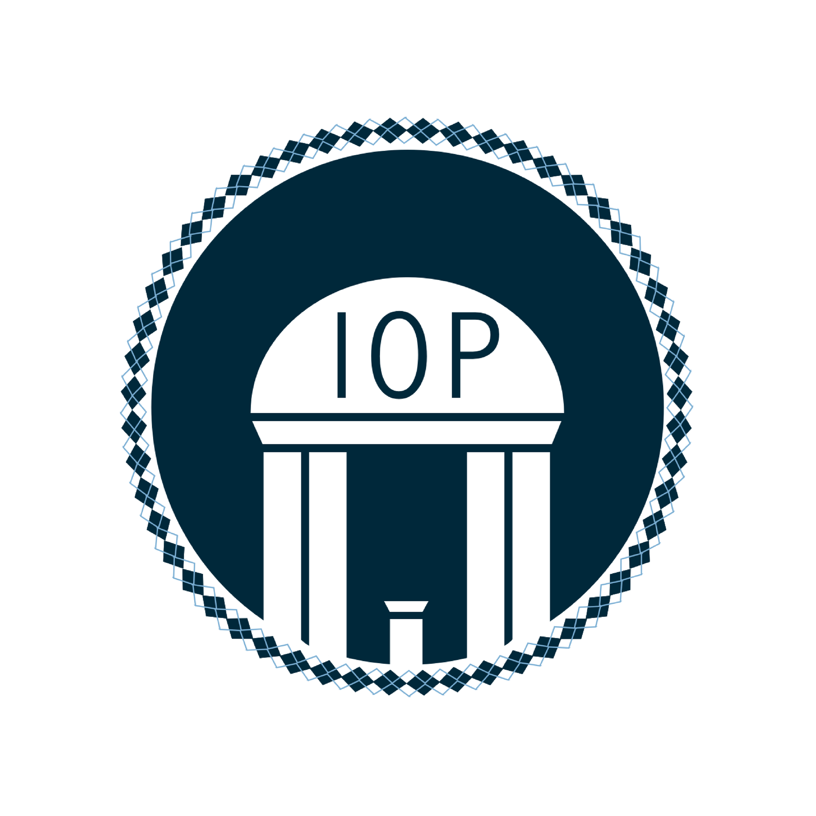
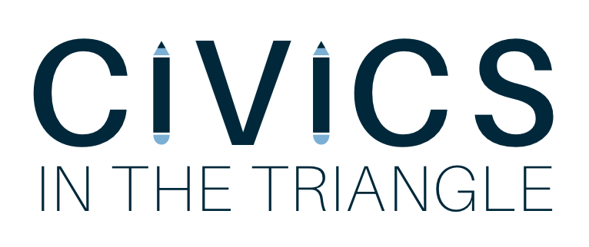

"The practice of democracy is not transferred through the gene pool. It must be taught and learned anew by each generation of citizens.” - Justice Sandra Day O’Connor

Program Description
Civics in the Triangle is a newly formed organization that is launching in Fall 2017 under UNC-Chapel Hill’s nonpartisan Institute of Politics. The program will place motivated undergraduates in elementary school classrooms to teach history, civics, and government lessons. We aim to inspire students to immerse themselves in their local communities and grow into active participants in our democracy.
We believe that it is our responsibility to equip the next generation--the future leaders of North Carolina and our country--with the knowledge and skills to become engaged citizens. By facilitating dialogues about our roles in our communities, we hope to promote civic engagement at a young age.
Civics in the Triangle is modeled after Harvard University’s corresponding CIVICS program, a similar student organization under its Institute of Politics. While Harvard’s program has existed for several years and operates at a much larger scale, it serves as an enlightening example for the development of our program and a program to strive toward.
The program will work with two public schools in the Chapel Hill/Carrboro area during the 2017-2018 school year. We are tailoring our program to meet the needs of 4th and 5th grade classrooms over a four-week long period in the fall and eight-week long period in the spring. The program will recruit eight UNC volunteers to work in pairs and teach the civic engagement course material. They will teach 45-minute long lessons once a week.
We have decided to only select eight students to teach in the pilot program for Civics, as we want to ensure quality is prioritized over quantity. We believe that the CHCCS system and UNC-Chapel Hill should capitalize on their close proximity in order to create a unique, dynamic partnership. At UNC, we can provide passionate undergraduates who can serve as mentors to the bright students in CHCCS, forging a rewarding bond between the two institutions.
Curriculum
We want to provide lessons that are relevant, interactive, and engaging for our students. Our curriculum will be organized, easy to teach, and consistent between different classrooms.
The three pillars of our curriculum are: civics, American history, and government. There will be separate curriculums for the 4th and 5th grades, adjusted accordingly for their educational levels and maturity. The lessons will supplement the North Carolina 4th and 5th grade Social Studies courses with the introduction of additional dynamic instruction strategies to assist teachers.
In order to draft these lessons, we have partnered with Carolina K-12 (formerly the NC Civic Education Consortium), a program of UNC-Chapel Hill’s Carolina Public Humanities that works to extend the resources of the University to North Carolina’s K-12 educators. Carolina K-12 is providing supplemental texts and other materials in order to enhance the students’ learning, such as pocket constitutions geared towards children in elementary school. Another resource, a website founded by Justice Sandra Day O’Connor called iCivics, provides teachers with well-written, inventive, and free online resources online to enhance their classrooms.
We have developed the curriculum with the following in mind: the North Carolina Literacy Standards, the spiraling of 4th and 5th grade social studies strands, and the North Carolina Essential Standards. We have aimed to supplement these standards with dynamic, engaging material that pertains to civics, emphasizing the overlapping of social studies with literacy. We will utilize a variety of methods to underscore the standards: oral narratives, poetry related to North Carolinian (4th) and American (5th) history, classroom debates, a variety of primary sources and more. The lesson structure for Fall 2017 is the following: Constitution 1--Structure and Function, Constitution 2--Bill of Rights, Current Structures of Government, North Carolina State Government.

Important General Dates Fall 2017:
• Tuesday, August 22: First day of class for UNC-Chapel Hill students
•Wednesday, August 23: IOP Application Launches
•Friday, September 1: IOP Application Closes
• Friday, September 15-17: Civics volunteer interviews and decisions (17th)
• Monday, September 18: Civics full team meeting

