ITAL 781

ITALIAN ROMANTICISM

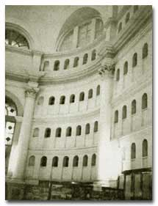

Hours: Tu-Th 11:00 - 12:15 PM
Instructor: Federico Luisetti
Office: Dey Hall, 123
luisetti@email.unc.edu
Office hours: Tuesday 3:15 - 4:15 and by appointment

COURSE DESCRIPTION
Against the background of Michel Foucault’s account of disciplinary practices and through a close-reading of some of the most significant novels of Italian Romanticism, the course will address the multiple connections between literary forms and forms of power.
COURSE REQUIREMENTS
Course lectures and readings will be in Italian. Participation in class discussions is essential to your grade.
You will write 3 short presentations (3 pages each) that you will discuss in class, a complete take-home midterm (5 pages) and a final paper (15 pages).
GRADING DISTRIBUTION
• Attendance and participation (including class presentations) 20%
• Short papers 25%
• Midterm paper 25%
• Final paper 30%
TEXTBOOKS
M. Foucault, Sorvegliare e punire, Einaudi 1993
A. Manzoni, I promessi sposi, Feltrinelli 2007
I. Nievo, Confessioni di un italiano, BUR 2007
S. Pellico, Le mie prigioni, Mondadori 1986

Please visit the blackboard site for the course (blackboard.unc.edu). The site will contain all pertinent course information, including weekly class reading assignments, electronic resources and announcements

