THE DAILY TAR HEEL

Phi Mu celebrates 50th anniversary on campus
UNC’s chapter of Phi Mu celebrated 50 years of service and friendship.
BY PAIGE HOPKINS | PUBLISHED 11/17/14

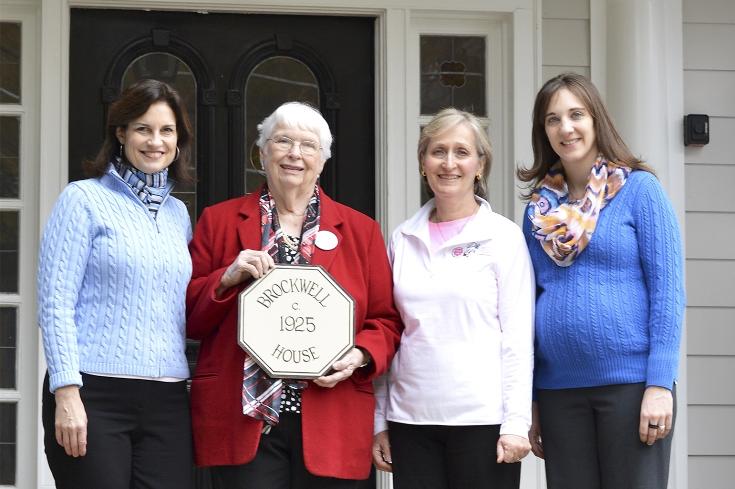
Debra Pickrel, alumna chair and president of Gamma Lambda Chapter Association, Nanette Fields, first house corporation director, Karen Dias, house corporation board member and Cheri Szcodronski, Executive Director of Preservation Chapel Hill pose with the Brockwell plaque award for preservation after the Phi Mu 50th Anniversary brunch Sunday.
Photo by Ivana Chan

Homecoming wasn’t the only reason to celebrate this weekend.

The Gamma Lambda chapter of Phi Mu fraternity celebrated its 50th anniversary Friday and the Panhellenic women’s organization hosted multiple events throughout the weekend, including a ball at the George Watts Hill Alumni Center.

Three years of work went into the planning of this weekend’s events. Phi Mu also received a special proclamation from Chapel Hill Mayor Mark Kleinschmidt declaring Nov. 14 as Phi Mu Gamma Lambda Chapter Day.

Debra Pickrel is the alumnae chair of the Phi Mu 50th Anniversary Celebration and the president of the Gamma Lambda Chapter Association. She said Phi Mu sets itself apart from other Greek organizations.

“I think that each Greek organization has its own personality so the characteristics of being ambitious, inclusive and spirited, along with our outstanding philanthropic heritage, are what make us unique,” said Pickrel, who authored a commemorative book about UNC’s Phi Mu chapter. “Any organization might pick one of those words, but for us it’s the combination of those descriptors that set us apart.”

The organization came to UNC in 1964. Pickrel said the climate of change and progressive movements during which Phi Mu was colonized at UNC in some ways shaped the organization.

“We came to campus in a decade that changed America. And that time helped shape us in the ways I described — as ambitious, inclusive and spirited. It helped develop our character,” Pickrel said.

In order to commemorate the exact date of the founding of Phi Mu, the organization held a commemorative tea and Chancellor Carol Folt spoke at the event.

Taylor Brundage, a senior English major and collegian co-chair for Phi Mu, said it was great to see some of the founding members of Gamma Lambda sitting with other alumnae and current members of the organization at the tea.

“It was really cool to see these women from all of these years come together. It was like no time was lost,” she said.

Pickrel said Phi Mu has many rich traditions which help create a bond between the members.

“One of the things I treasure most is how our relationships have grown all the richer since college and that is born from the shared traditions we had when we were young,” she said.

As an out-of-state student from Florida, Caitlyn Balsay said Phi Mu provided her with a great way to make lifelong friends upon arriving at UNC.

A a senior biology major and the collegian co-chair, she said the organization brings together diverse groups of women.

“I didn’t know a soul (at UNC),” she said. “It sounds so cliche to go and join a sorority but this is really where we met all of our best friends.”

Balsay said lots of hard work went into the planning for the events. She said the weekend was a great way to bring alumnae and current students together to celebrate and remember.

“I was just proud to have been on campus for 50 years. And this was to celebrate those 50 years and everything that happened during them.”

arts@dailytarheel.com

